**Chapter 1**

**INTRODUCTION**

**Background of the Study**

Parking in an unshaded area gave rise of greenhouse problem. Temperature inside the vehicle cabin is very important to provide comfort to the car passenger. The temperature can be controlled by using air conditioning system that can be operated when the car engine is in operation. The most hot air was accumulated in the top part of the cabin. However, when the car is left or parked directly under the sunlight, temperature inside the cabin will increased. Sealed automobiles commonly encounter interior temperature conditions that are tremendously uncomfortable to the passengers.

In local scenario, private passenger vehicles that are park in an open area or parked directly under the sunlight face an incidents caused from a high temperature of a cabin components which delivers different cases of illness like cancer, anemia and hyperthermia. Hyperthermia is an acute condition that occurs when the body absorbs more heat than it can handle. Annually, hundreds of children and pets experience varying degrees of heat illness from being left in cars.

Based on the study, Benzene is the most active toxin present in car dashboard, sofa and air freshener. It evaporates quickly when exposed to air. Mainly used as a starting material in making other chemicals, including plastics, lubricants, rubbers and pesticides. It is the problem of conversion of solar radiation entering through the windows of a car into long wave thermal radiation and trapped inside car cabin causes temperature increase of cabin components.

The high density of private passenger vehicles leads to lack of parking space, this is much clearer at the government, offices, universities and shopping areas. Moreover, the available shaded parking areas do not match the existing number of vehicles hence the alternative choice for those who are unable to park under shaded area is to park in an open parking space.

Therefore, the proponents are motivated to design and develop a Car Interior Temperature Controlling System with Anti-Theft Technology to maintain the temperature inside the car at comfortable level in order to help the car owners to avoid unnecessary health problem when entering their cars which are parked in an unroofed parking spaces. The obtained improvements from suggesting method were increasing in passenger comfort and less thermal stress on car interior components. Also, lower initial automobile air conditioner loads and reduction in fuel consumption and carbon dioxide emissions.

**Theoretical Framework**

According to Ammar A. Farhan (2008), temperature inside the vehicle cabin is very important to provide comfortable conditions to the car passengers. Temperature inside the cabin will increased when the car is left or parked directly under the sunlight. Experimental studies were performed in Baghdad, Iraq to investigate the effects of solar radiation on car cabin components. The test vehicle was oriented to face south to ensure maximum sunload on the front windscreen. A suggested car cover was examined experimentally. The measurements were recorded for clear sky summer days started at 8 A.M. till 5 P.M. Results show that interior air temperature in unshaded parked car reaches 70 degrees Celsius and dashboard temperature can approach up to 100 degrees Celsius. While, cardboard car shade inside the car does not reduce the air temperature inside it. Suggested car cover with 1 cm part-down side windows reduced temperature of cabin components by 70% in average compare to the base case. To determine the most technically feasible passive method in reducing the car interior temperature.

Six cases were experimentally studied; unshaded, partial shaded (inside and outside), total shaded (shelter and novel cap). The cabin temperature of unshaded parked car can quickly rise to a level that may damage property and harm children or pets left in the car. The obtained improvements from suggesting method were increasing in passenger comfort and less thermal stress on car interior components. Also, lower initial automobile air conditioner loads and reduction in fuel consumption and CO2 emissions.

**Conceptual Framework**

Figure 1 consists of input, process and moderated output of the study. Input contains the knowledge requirement, software requirement and the hardware requirement. Process is the series of action or steps taken in order to achieve a particular end in the study. Last is the output of the study.

**OUTPUT**

**PROCESS**

**INPUT**

Knowledge Requirement

* Object Oriented Programming

Software Requirements

* Arduino

Hardware Requirements

* Temperature Sensor
* Power Supply
* Battery 12VDC
* Microcontroller
* TEC Module
* Water Cooling System
* GSM Module
* PIR Sensor
* Bluetooth Module
* Relay Module

Research

Design a system to control and monitor the car interior temperature

Test the reliability of study

**Car Interior Temperature Controlling System with Anti-Theft Technology**

**Fig. 1. Research Paradigm of the Study**

Input represents the major components of the knowledge requirement which consists of Object Oriented Programming, also represents the major components of the software requirements in this study which consists of Arduino and the major components of the hardware requirements which consist of temperature sensor, power supply, battery 12VDC, microcontroller, TEC module, water cooling system, GSM module, PIR sensor, bluetooth module and relay module. The requirements given above had be used in programming and installing of the project.

Process represents the design of the system to monitor and control the temperature of the car interior. Process is also test the reliability of the finished product.

Output represents the final output of the study which is the completed Car Interior Temperature Controlling System with Anti-Theft Technology that can be used to monitor and control the car interior temperature.

**Objectives of the Study**

To design and develop the Car Interior Temperature Controlling System with Anti-Theft Technology. Specifically, it aims to achieve the following:

1. To determine the Coefficient of Performance of the cooling system.
2. To test the reliability of the system in terms of:
   1. Anti-theft Device
   2. SMS Transmission

**Significance of the Study**

The study of **Car Interior Temperature Controlling System with Anti-Theft Technology** is beneficial to the following:

**Car Owners**

This study will help the car owners to easily monitor and control the temperature of the machine inside the car.

**Future Researchers**

Future researchers will benefit with this study information. It will serve as a reference material who wish to improve and develop this study.

**University**

The concept of the system or machine can be used as a teaching aid by the professors in the university.

**Scope and Limitations**

The proposed system managed the process of the Car Interior Temperature Controlling System with Anti-Theft Technology. It uses a thermoelectric cooling device that is powered by a 12V DC battery. It also uses a water cooling system with a 12V power input. The system is portable, small and easy to carry around. The system can also view and change the temperature of the cooling system via mobile application that is suitable in their needs. It uses a SMS notification as a warning if there is a motion inside your vehicle for the anti-theft technology.

**Operational Definition of Terms**

For having clear understandings of this study, the followings terms are defined:

**Arduino.** It is a single-board microcontroller for building the digital devices and interactive objects that can sense and control objects.

**Battery 12VDC.** It is used as the main source of power for this study.

**Bluetooth Module.** It is used as a transparent wireless serial connection setup for the system.

**Microcontroller.** It is used for building digital devices and interactive objects that can control objects in physical form.

**GSM Module.** It is used to establish communication between the mobile device and the system.

**Object Oriented Programming.** It is a programming language model organized around objects rather than actions and data rather than logic, and is used in this study.

**PIR Sensor.** It is used as motion detectors for the system.

**Power Supply.** It is an electrical device that supplies electric power to the Arduino.

**Relay Module.** It is used for remote device switching to remotely control the system.

**TEC Module.** It is a semiconductor-based electronic component that functions as a small heat pump, moving heat from one side of the device to other.

**Temperature Sensor.** This component provides for temperature measurement through an electrical signal and is used to measure the temperature in the car interior.

**Water Cooling System.** It is a method of heat removal from components, this is also used as the heat conductor for the study.

**Chapter 2**

**REVIEW OF RELATED LITERATURE AND STUDIES**

Literatures and studies down below reviewed by the proponents has a connection and relationship to the present study. It gives the proponents information that will help them have clear understandings about the study.

**Object Oriented Programming**

According to Yaiser (2011), object-oriented programming (OOP) is a style of programming that focuses on using objects to design and build applications. Think of an object as a model of the concepts, processes, or things in the real world that are meaningful to your application. For example, in a project management application, they would have a status object, a cost object, and a client object among others. These objects would work together (and with many other objects) to provide the functionality that they want their project management application to have.

According to Rouse (2008), the programming challenge was seen as how to write the logic, not how to define the data. Object-oriented programming takes the view that what they really care about are the objects they want to manipulate rather than the logic required to manipulate them. Examples of objects range from human beings (described by name, address, and so forth) to buildings and floors (whose properties can be described and managed) down to the little widgets on a computer desktop (such as buttons and scroll bars).

According to Wazlawick (2014), it is not sufficient to organize the system architecture in tiers and modules if the code implemented inside of it is disorganized. Some programmers organize the system adequately in classes and packages, but they still write spaghetti code inside the methods of these classes and packages. In addition, other developers still use top-down functional decomposition inside methods, which is not appropriate when using object-oriented programming (top-down decomposition is adequate if structured programming is used instead). In order to build code that is really object-oriented, developers should learn the techniques of delegation and responsibility assignment, which can lead to reusable code and low coupling.

According to Eng (2018), In OOP, they must identify opportunities to encapsulate data and functions in a reasonable manner. They may draw inspiration from the real world. They may apply creativity and imagination. Whatever works for them. They will find that OOP is merely an extension of procedural programming and modules. It is not as hard as they think it is, especially if they use Smalltalk and not one of the major languages like Java, Python, C++, and C#.

According to Yang (2018), OOP is concerned with composing objects that manages simple tasks to create complex computer programs. An object consists of private mutable states and functions (called methods) that operate on these mutable states. Objects have a notion of self and reused behavior inherited from a blueprint (classical inheritance) or other objects (prototypal inheritance).

The above studies and literature explain that Object-Oriented Programming is a style of programming. It focuses more on using objects in creating an application rather than the logic behind them.

**Arduino**

According to the study entitled “DEVELOPMENT OF AN ARDUINO-BASED EMBEDDED SYSTEM Case: Greenhouse monitoring, Kouhia and Pekka (2016), to create a microcontroller-based embedded system for monitoring greenhouse environmental variables. The user can control the greenhouse environment through a web-site. The website displays monitoring data to the user on a 24-hour line chart. Theory explains the use of Arduino microcontroller and how it is used in embedded systems. The practical part of the project introduces which hardware components are used and how they are used to build the system.

According to the study entitled “Development of an Autonomous Plant-Robot Hybrid System for Plant-Human environment Studies” by (Zhang, 2014). Since the plant-robot hybrid system needs to associate with large portion of input/output pins which comes from several kind and number of sensor/electronics. Arduino Mega becomes an ideal choice for its total 54 digital pins that can be freely used as input/output pins and its various interfaces provided.

According to What is Arduino, Arduino (2016). arduino is an open-source electronics platform based on easy-to-use hardware and software. Arduino boards are able to read inputs, light on a sensor, finger on a button, or a twitter message - and turn it into an output - activating a motor, turning on a LED, publishing something online. They can tell your board what to do by sending a set of instruction to the microcontroller on the board.

According to The Making of Arduino, David Kushner (2011), with Arduino, even those with no previous electronics experience gained access to a previously impenetrable hardware world. Now, beginners don’t have to learn much before they can build a prototype that works. It’s a powerful movement at a time when some of the most popular gadgets out there work as “black boxes” that are closed, and patent protected.

According to the study entitledNeural Network based Closed loop Speed Control of DC Motor using Arduino Uno, Neerparaj Rai and Bijay Rai (2013) the design and implementation of Arduino Uno based DC motor speed control system using Multilayer Neural Network controller and PID controller. A model reference structure is developed using PID control to obtain the neural controller. The artificial neural network is trained by Levenberg-Marquardt back propagation algorithm. Feed forward neural network with two hidden neurons and one output neuron is used. Speed of the dc motor is controlled by varying the duty cycle of the pwm signal which is fed to the gate of the mosfet irf 640. Simulation and practical results are presented to demonstrate the effectiveness and advantage of the control system of DC motor with ANNs in comparison with the conventional control scheme in Matlab/Simulink R2009b. PID algorithm and ANN controller is implemented in Arduino Uno because of its easy compatibility and portability

This study is linked to the present study because it helps the proponents and the future researchers understand more about Arduino.

**Temperature Sensor**

According to Anjali Rai (2017) on an article “What is Temperature Sensor?” it is a device which is used for the measurement of temperature or heat, such as RTD (Resistance temperature detectors), thermocouple, thermistor, sensistors etc.

The electrical resistance of some materials such as platinum, copper, and nickel differs at different temperatures. Resistance temperature detectors (RTDs) take advantage of this property to assess temperature.

A thermocouple is made from two dissimilar metals that generate electrical voltage in direct proportion to changes in temperature. When the two junctions are at different temperatures, a voltage is developed across the junction which is used to measure the temperature. Its working principle is based on Seebeck effect.

Thermistors are made up of intrinsic semiconductors. When the temperature of intrinsic semiconductor is increased its conductivity increases which means resistance decreases. Hence thermistors have negative temperature coefficients of temperature of resistance. Thermistors are rated by their resistive value at room temperature, their time constant (the time to react to the temperature change) and their power rating with respect to the current flowing through them.

Sensistors are made up of heavily doped semiconductor. It has positive temperature coefficients of temperature of resistance because when temperature of doped semiconductor is increased its conductivity decreases (resistance increases).

According to Carolyn Mathas (2011) on an article “Temperature Sensors: The Basics”, Temperature sensors are used in diverse applications such as food processing, HVAC environmental control, medical devices, chemical handling and automotive under the hood monitoring (e.g., coolant, air intake, cylinder head temperatures, etc.). Temperature sensors tend to measure heat to ensure that a process is either; staying within a certain range, providing safe use of that application, or meeting a mandatory condition when dealing with extreme heat, hazards, or inaccessible measuring points.

In accordance to “Temperature Sensors” written by Anshul Thakur (2012), the world is getting warmer day by day.’ This sentence has started to crop up every now and then in our day to day lives. But seldom do they wonder what it means. What is warmer? How warm is warm? Is it hotter than hot, or just hotter than cold? To our human senses, temperature is only a subjective evaluation. For an objective and reproducible measurement, they need to quantify the temperature values, and to do that, a suitable measurement device is required.

Simply speaking, temperature is the degree of hotness of the body which is a measure of the heat content in the body. The problem to quantify the heat content of the body on a scale did not arise until the invention of the Steam Engine. The curiosity of scientists to understand the behavior of water at different levels of heat contents gave rise to a formal and better laid out study. One of the first references for ‘temperature’ dates back to 1760, when Joseph Black declared that applying the same heat to different materials resulted in different temperatures. Years of rigorous scientific study led to many theories ranging from the simple ‘Caloric’ concept, which treated heat as a material substance which is exchanged among materials, to Carnot’s description of heat as a form of energy (which laid the foundation of the first law of thermodynamics). However, none of them satisfactorily explained the concept of temperature. It was Maxwell’s theory which offered good reasoning into it. He defined temperature of a body as is its thermal property which provides information about the energy content of the system. It is the measure of the average kinetic energy (energy by virtue of motion) of the molecules of the substance and signifies a heat potential due to which heat flows from higher temperature to lower temperature.

According to Nick Davis (2017) on his article, “Introduction to Temperature Sensors”, Temperature sensors are among the most commonly used sensors. All types of equipment use temperature sensors, ranging from computers, cars, kitchen appliances, air conditioners, and (of course) home thermostats. The five most common types of temperature sensors include: Thermistor, Thermocouple, RTDs (resistive temperature detectors), Digital thermometer ICs, Analog thermometer ICs.

According to Ashleigh Hayes (2013) on his respond on an article “Which kind of temperature sensor is the most accurate?”, while the reader brings up a valid argument for TC accuracy, it is important to remember the applications and industry they are addressing. Both RTD’s and TC’s have advantages and limitations in what they can do; the key is to select the right solution for the specific application and industry the measurement is being taken in.

To his specific point, TC’s are able to maintain high accuracy if they are operated under specific, controlled conditions and monitored regularly. In a lab environment this can be done as the conditions are controlled and someone can check, and potentially replace, the TC frequently. Along with that, in a lab environment ice baths can be used for cold junction compensation which helps to provide a highly accurate measurement.

When speaking about process industries and a typical environment such as an oil refinery, this kind of monitoring and testing is not feasible. Often temperature sensors are installed into the process and left for very long periods of time. At the time of installation, a TC may be of a similar accuracy as an RTD, however over time the degradation of the TC will lead to the RTD being more accurate.

Thus, temperature sensor will be needed to measure and necessary output of temperature in the study which will be used in Car Interior Temperature Controlling System with Anti-Theft Technology.

**Power Supply**

According to an article, Power Supplies, Coates (2017), ideally, a DC Power Supply Unit (commonly called a PSU) deriving power from the AC mains (line) supply performs a number of tasks: 1. It changes (in most cases reduces) the level of supply to a value suitable for driving the load circuit. 2. It produces a DC supply from the mains (or line) supply AC sine wave. 3. It prevents any AC from appearing at the supply output. 4. It will ensure that the output voltage is kept at a constant level, independent of changes in: a. The AC supply voltage at the supply input. b. The Load current drawn from the supply output. c. Temperature.

Power supplies in recent times have greatly improved in reliability but, because they have to handle considerably higher voltages and currents than any or most of the circuitry they supply, they are often the most susceptible to failure of any part of an electronic system.

Modern power supplies have also increased greatly in their complexity and can supply very stable output voltages controlled by feedback systems. Many power supply circuits also contain automatic safety circuits to prevent dangerous over voltage or over current situations.

According to Mark Hennessy (2017), Power Supply Basics, Power supplies are an essential part of any piece of electronic equipment, and while it's easy to take them for granted, it's surprising how complicated power supplies can be. This article discusses the basics of power supplies with an audio slant - it's particularly appropriate for people experimenting with "chip-amps".

While the power supplies found in audio amplifiers might look simple, there is more to them than meets the eye and it's vitally important to get the design right. Consider this: all the energy delivered to your loudspeakers comes from the power supply - the power amplifier circuit is just like a "tap", controlling the flow of energy.

With chip-amp based power amplifiers, the power supply is more important than usual. When designing a discrete amplifier, they can build in a high level of power supply immunity - for example the critical input stage and voltage gain stages can be highly isolated from the noisy output stage with simple R-C filters. But this isn't an option with most chip-amps where the power supply pins are shared with the high and low current circuitry.

According to Alan Moloney (2009), Power Supply Management—Principles, Problems, and Parts, power supply designers are using flexible supply monitoring, sequencing, and adjustment circuits to manage their systems. This article discusses why and how.

The monitoring and control of a growing number of power-supply voltage rails has been vital for safety, economy, durability, and proper operation of electronic systems for many years—especially for systems employing microprocessors. Determining whether a voltage rail is above a threshold or within an operating window—and whether that voltage is powered on or off in the correct sequence with respect to the other rails—is crucial to operational reliability and safety.

Many methods exist to solve various aspects of this problem. For example, a simple circuit using a precision resistive divider, comparator, and reference can be used to determine whether the voltage on a rail is above or below a certain level. In reset generators, such as the ADM803, these elements are combined with a delay element to hold devices—such as microprocessors, application-specific ICs (ASICs), and digital signal processors (DSPs)—in reset while powering up. This level of monitoring is adequate for many applications.

According to Everything You Need to Know About Power Supplies, Gabriel Torres (2008), as an electrical device, the computer needs power in order for its components to operate properly. The device responsible for supplying power to the computer is the power supply. In short, they could say that the main function of the power supply is to convert alternating voltage (a.k.a. AC), which is supplied by the electrical power system into continuous voltage (a.k.a. DC). In other words, the power supply converts the conventional 110V or 220V alternating voltage into continuous voltage used by the PC electronic components, which are +3.3 V, +5 V, +12 V and -12 V (Alternating voltages vary throughout the world. In this tutorial, they will use “110 V” as a catchall label for 110 V, 115 V and 127 V voltages, whereas they will use “220 V” as a catchall label for 220 V, 230 V and 240 V voltages. Japan, which uses a 100V power grid, is the only country outside this range.) The power supply is also present in the PC cooling process, as they will explain in detail later.

According to Build a Simple DC Power Supply, Vin Marshall (2010), a power supply, as we'll be referring to it here, converts alternating current from the outlet on the wall into direct current. There are several ways to do this. They are going to look at one of the simplest, but also most illustrative.

Electricity passes through several stages in a voltage regulator type power supply like this one, or like the common wall-wart. The ways in which it is altered by each stage are explained below. The next time you use a wall-wart to power one of your projects, you will understand what is happening inside.

Thus, power supply will be needed to supply the regulated and necessary output of power needed by the circuit board which will be used in Car Interior Temperature Controlling System with Anti-Theft Technology.

**Battery**

According to How Batteries Work, Marshall Brain, Charles W. Bryant & Clint Pumphrey (2018), Imagine a world where everything that used electricity had to be plugged in. Flashlights, hearing aids, cell phones and other portable devices would be tethered to electrical outlets, rendering them awkward and cumbersome. Cars couldn't be started with the simple turn of a key; a strenuous cranking would be required to get the pistons moving. Wires would be strung everywhere, creating a safety hazard and an unsightly mess. Thankfully, batteries provide them with a mobile source of power that makes many modern conveniences possible.

While there are many different types of batteries, the basic concept by which they function remains the same. When a device is connected to a battery, a reaction occurs that produces electrical energy. This is known as an electrochemical reaction. Italian physicist Count Alessandro Volta first discovered this process in 1799 when he created a simple battery from metal plates and brine-soaked cardboard or paper. Since then, scientists have greatly improved upon Volta's original design to create batteries made from a variety of materials that come in a multitude of sizes.

According to Battery Basics: A Layman's Guide to Batteries, Layman (2018), if they have done any research on how batteries work or what they should look for when selecting a battery, they are probably buried in information, some of which is conflicting. At BatteryStuff, they aim to clear that up a bit.

They are most likely heard the term KISS (Keep It Simple, Stupid). They are going to attempt to explain how lead acid batteries work and what they need, without burying them with a bunch of needless technical data. They have found that battery data will vary somewhat from manufacturer to manufacturer, so they will do my best to boil that data down. This means they may generalize a bit, while staying true to purpose.

According to Building a better battery layer by layer, Dae-wook Kim, Shuhei Uchida, Hiromasa Shiiba, Nobuyuki Zettsu, Katsuya Teshima (2018), Lithium-ion batteries are very promising energy storage systems for electric vehicles that require relatively high energy densities," said the study's author Nobuyuki Zettsu, a professor in the CEES and in the Department of Materials Chemistry at Shinshu University. "However, their high operating voltages commonly result in the oxidative decomposition of the electrode surface, which subsequently promotes various side reactions."

Lithium-ion batteries store a lot of energy, but the force it takes to make the battery disperse the energy is too much - so much, in fact, that the resulting damage makes the battery lose storage capacity.

According to Battery, Margaret Rouse (2018), a battery is an electrochemical cell (or enclosed and protected material) that can be charged electrically to provide a static potential for power or released electrical charge when needed.

According to Batteries, Chris Woodford (2018), no cellphones, laptops, or flashlights. No electric cars or robot vacuums. No quartz watches, pocket calculators, or transistor radios. And, for those of them who need a helping hand with our daily lives, no heart pacemakers, hearing aids, or electric wheelchairs.

Life without batteries would be a trip back in time, a century or two, when pretty much the only way of making portable energy was either steam power or clockwork. Batteries—handy, convenient power supplies as small as a fingernail or as big as a trunk—give them a sure and steady supply of electrical energy whenever and wherever they need it. Although they get through billions of them every year and they have a big environmental impact, they couldn't live our modern lives without them.

According to Battery, Computer Hope (2017), a battery is a hardware component that supplies power to a device, enabling that device to work without a power cord. Batteries are often capable of powering a laptop computer for several hours depending on how much power it requires. Today, many high-end devices such as computer laptops and cell phones use rechargeable batteries that allow a user to recharge the battery once depleted of energy. The picture below is an example of what a laptop battery may look like when removed from the laptop, with a close-up of the battery rating.

Battery will be needed to supply the regulated and necessary output of power needed by the circuit board and will be the main source of energy which will be used in Car Interior Temperature Controlling System with Anti-Theft Technology.

**Microcontroller**

According to Kushner (2011).With Arduino, even those with no previous electronics experience gained access to a previously impenetrable hardware world. Now, beginners don’t have to learn much before they can build a prototype that works. It’s a powerful movement at a time when some of the most popular gadgets out there work as "black boxes" that are closed, and patent protected.

Shahrara (2011) stated in his study of Design and Implementation of a Microcontroller Based Wireless Energy Meter that efficient use of energy becomes more crucial when increase in the cost of energy is observed. Since energy management is required to define the amount of consumed energy in a specific period of time, utilization of Energy Meters is essential. It is possible to measure the consumed energy by using a simple energy meter. But sometimes the limited functionality of these meters restricts their area of application; especially in inaccessible positions or in the situations where visibility of the meter is poor, it is not possible to use such an appliance.

A possible solution is a Wireless Energy Meter (WEM) which is able to send its data via wireless communication to a PC where monitoring and analysis of the data will be easily made. This measurement system is aimed to be used in measuring energy related quantities of transformers and high voltage towers at remote locations.

According to Arduino (2016)Arduino is an open-source electronics platform based on easy-to-use hardware and software. Arduino boards are able to read inputs, light on a sensor, finger on a button, or a twitter message - and turn it into an output - activating a motor, turning on a LED, publishing something online. They can tell the board what to do by sending a set of instruction to the microcontroller on the board.

According to the study entitled"Development of an Arduino-Based Embedded System Case: Greenhouse monitoring" by (Kouhia and Pekka, 2016) to create a microcontroller-based embedded system for monitoring greenhouse environmental variables. The user can control the greenhouse environment through a web-site. The website displays monitoring data to the user on a 24-hour line chart. Theory explains the use of Arduino microcontroller and how it is used in embedded systems. The practical part of the project introduces which hardware components are used and how they are used to build the system.

Hoque Mohammad Murahidul (2014) stated in his study of Design, Implementation and Performance Study of Programmable Automatic Voltage Regulator that current systems available locally lack precision and suffer the problem of oscillating between two output voltages and hence creating surge at the output which can damage valuable electronics. To avoid these, the stabilization of power voltage, minimization of output wave rate and unchangeable power-voltage to the instruments are needed while the load changes. That requires the maintenance of stable voltage and rapid reaction against the sudden change of input voltage and load.

This study is linked to the present study because it helps to understand that microcontroller is usually used to control a single process and execute simple instructions and they do not require significant processing power.

**Thermoelectric Module**

According to Chen (2012) thermoelectric modules are useful devices to recover low-temperature waste heat for power generation. To understand the characteristics of power generation from thermoelectric modules (TEMs), the performances of TEMs at various flow patterns, heating temperatures, flow rates of water and numbers of modules in series are studied experimentally. The results show that the effects of flow pattern of heat sink and water flow rate on the performance are not significant, but the heat source or heating temperature plays an important role. Therefore, a lower water flow rate is suggested to save power, whereas a higher hot-side temperature which leads to a larger temperature difference is recommended to give better performances of TEMs. Increasing number of modules in series provide higher output power. However, the performance of the modules in series cannot be simply predicted using linear superposition due to the Peltier effect and the non-uniformity of every module. The feature of a thermoelectric generator (TEG) is also examined and compared with the TEMs. It is found that TEM is a better choice for power generation from recovering waste heat if the temperature of a system is below 150oC.

Wang (2012) Thermoelectric (TE) devices can provide clean energy conversion and are environmentally friendly; however, little research has been published on the optimal design of air-cooling systems for thermoelectric generators (TEGs). The present study investigates the performance of a TEG combined with an air-cooling system designed using two-stage optimization. An analytical method is used to model the heat transfer of the heat sink and a numerical method with a finite element scheme is employed to predict the performance of the TEG. In the first-stage optimization, the optimal fin spacing for a given heat sink geometry is obtained in accordance with the analytical method. In the second-stage optimization, called compromise programming, decreasing the length of the heat sink by increasing its frontal area is the recommended design approach. Using the obtained compromise point, though the heat sink efficiency is reduced by 20.93% compared to that without the optimal design, the TEG output power density is increased by 88.70%. It is thus recommended for the design of the heat sink. Moreover, the TEG power density can be further improved by scaling-down the TEG when the heat sink length is below 14.5 mm.

Thus, thermoelectric module will function as a small heat pump, moving heat from one side of the device to other for this study.

**Water Cooling System**

Ram (2016) in an automobile engine, the heat transfer cannot be possible without cooling system support. The cooling system has a great importance in the engines. It coolants overheat of the engine, and prevents it from breakdown, that's why a highly reliable cooling system is the necessity of every engine but there are many failure issues with a cooling system which are time dependent. This paper investigates the performance of a water cooling system with the consideration of their significant components by taking the attention of three types of time dependent failure issues while the water cooling system is maintained by the sufficient repair facility. It is obvious that in the lack of maintenance, failure issues in water cooling system lead with the increment of time. Maintenance and operating costs of water cooling system affect the economy of overall engine very much, so, it is necessary to be aware about overheating of engines during peak ambient conditions when it is operated with full capacity. Hence, a Mathematical model of water cooling system is proposed by using the Markov process and supplementary variable technique. © 2016, IGI Global. Copying or distributing in print or electronic forms without written permission of IGI Global is prohibited.   
 Subbiah (2016) Cooling system of the engine is one of main essential systems for automobiles, which maintains the engine temperature to the sustain conditions. Hence the main objective of this project work is to propose a simple piping design with less number of connecting hoses and also to reduce coolant leakage. It is also proposed to change the piping material from aluminum alloy to mild steel which reduces the overall cost of the engine cooling system. Findings: The proposed design addresses the coolant leakage problem and reduces the number of parts used in coolant pipe connections hence leading to cost reduction and simplified design.

Thus, the water cooling system is a method of heat removal from components, this will be also used as the heat conductor for the study. A method of using water as a heat conduction to remove heat from the machine by passing cold water over or through it and which will be used in this study.

**GSM Module**

According to Prakash. H. Patil, Chaitali Borse, Snehal Gaikwad, Shilpa Patil (2013) Greenhouse Monitoring System Using GSM.A GSM modem is a wireless modem that works with a GSM wireless network. A wireless modem behaves like a dial-up modem. The main difference between them is that a dial-up modem sends and receives data through a fixed telephone line while a wireless modem sends and receives data through radio waves. Like a GSM mobile phone a GSM modem requires a SIM card from a wireless carrier in order to operate.

In accordance to Fareed (2017) GSM based Android Application: Appliances Automation and Security Control System using Arduino. Now-a-days, automation is playing significant role using android phone in human life, particularly, handicapped and senior citizens. Appliances automation allows users to control different appliances such as light, fan, fridge and AC. It also provides security system like door controlling, temperature & fire detection and water shower. Furthermore, security cameras are used to control and monitored by the users to observe activity around a house. It has been observed that the internet services in interior Sindh are not as much better as required. Hence, GSM SIM900A based android application is developed named Appliances Automation & Security Control System using Arduino. The developed system is decomposed into two separate entities: (1) hardware is designed and developed using Arduino (MEGA 2560) with other required electronics components which is programmed using embedded C language, (2) an Android app which provides freedom to user to control and access the electronic appliances and the security system without internet. The developed application is tested in Karachi, Sukkur and Khairpur with ZONG, Moblink, Telenor and Ufone. The acceptable results are achieved at Karachi and Sukkur but suitable results are not calculated at Khairpur in terms of delay due to the frequency of selected GSM Module.

According to Agnihotri (2010) in article GSM/GPRS Module: All You Need To Know. GSM/GPRS module is used to establish communication between a computer and a GSM-GPRS system. Global System for Mobile communication (GSM) is an architecture used for mobile communication in most of the countries. Global Packet Radio Service (GPRS) is an extension of GSM that enables higher data transmission rate. GSM/GPRS module consists of a GSM/GPRS modem assembled together with power supply circuit and communication interfaces (like RS-232, USB, etc) for computer. The MODEM is the soul of such modules. GSM/GPRS MODEM is a class of wireless MODEM devices that are designed for communication of a computer with the GSM and GPRS network. It requires a SIM (Subscriber Identity Module) card just like mobile phones to activate communication with the network. Also they have IMEI (International Mobile Equipment Identity) number similar to mobile phones for their identification.

Rathore (2015) in article REVIEW ON APPLICATION OF GSM FOR MONITORING SYSTEM. In today’s advanced world lots of innovative applications are built on mobile phone based technologies and more are being developed. Therefore mobile pervasive technology can be used in several areas. Hence, in this paper, they present about several GSM applications in various fields such as in medical field for detecting body temperature, heart beat rate, wireless ECG using Bluetooth which helps to make the patient monitoring devices more mobile. Several GSM based microcontroller are used for antitheft security system with text message as feedback and raise an alarm. GSM based city area monitoring system is another advantage.

Zulfikar (2014) A survey of GSM technology to control remote devices. This work describes the different design and implementation of a GSM based remote system. All existing systems either use GSM or GPRS technologies; however, GSM is the basic way of communication. Due to global GSM roaming facility and good network capability, there is virtually no requirement to build additional network. GSM based SMS services are very cheap and affordable; therefore transmission of data based on SMS in real- time application has become very popular. GPRS data transmission speed is much faster than normal text message, approx 28 to 32 SMS per/min may be achieve over GPRS. This study explore different tools and technique being used to control communication network through SMS. They also critically review the merit and demerit of various existing solution. The results of the study are reported in this paper.

**PIR Sensor**

Nepal (2013) Passive Infrared (PIR) Sensor Based Security System. In this paper, a PIR based security system which saves the power consumption and the memory space of the recording system has been proposed. Passive Infrared Radiation (PIR) sensor detects the change in infrared radiation of warm blooded moving object in its detection range. According to the change in infrared radiation, there will be a change in the voltages generated which was amplified and used to turn ON the webcam and lighting system through relay. Software was developed and installed in the computer to capture and record the video when the webcam gets turned ON. When an intruder comes in the detection range of the PIR sensor, it actuates the lighting system and the webcam. The software detects the webcam connection; it will start to record and save the video. Once the intruder moves out of detection range of the sensor, the webcam and light gets turn OFF. The software repeats the process. Thus the saves power consumption and the memory space of the recording system as the lamp and webcam will only get turned ON when PIR sensors detects an object. Consequently the system starts recording only when the webcam is turned ON; hence saving memory space.

Dellosa (2014) Development of an Anti-Theft Device using Motion Detection and Body Temperature. The researcher aimed to design, assemble and determine the performance of the anti-theft device using motion detection and body temperature. The study utilized developmental design to observe the functionality of the device. Study showed that the anti-theft device can detect motion from a moving object for those with body temperature like human being, animals. A signal from the sensor circuits will trigger the receiver circuit to produce an audible sound that served as alarm. It was also found out that the output of the study is accurate in terms of detecting moving objects with body temperature during day and night times. The researchers formulated an evaluation instrument to determine its performance. Results showed that the device had a good performance and acceptable in terms of functionality. It is strongly recommended that further studies be conducted to enrich the anti-theft device using motion detection and body temperature in a controlled environment like museum and banks to determine the effectiveness of the integration of the anti-theft device.

According to Hers (2013) in article New concept using Passive Infrared (PIR) technology for a contactless detection of breathing movement: a pilot study involving a cohort of 169 adult patients. A pilot study has been conducted to validate the Breath Motion Detecting System (BMDS), a new concept using Passive Infrared (PIR) technology for a contactless detection of respiratory movements. The primary objective of the study was to show if movements detected during sleep by the BMDS were indeed related to breathing. This medical device is not intended to measure the respiratory rate, but in a second step, it will be able to detect pathological central apnea in adults. One hundred and sixty-nine adult patients underwent a full polysomnography in which each respiratory movement was recorded concomitantly through the BMDS. Curves obtained by the BMDS were compared to those of thoracic movements recorded by classical piezoelectric belts and of pressure obtained with nasal cannula. The correlations between the PIR sensors were highly indicative of respiratory movement detection. Since PIR sensors are sensitive only to the exemplification of the rib cage, they did not detect obstructive apnea. Unfortunately, only a few patients in the studied population had a central apnea. Moreover as our sleep laboratory was equipped only with piezoelectric bands, the central apnea respiratory effort data are not a validated signal to be used during sleep recordings. The data recorded by the BMDS demonstrate the ability of the PIR technology to detect respiratory movements in adults. The concept is practical, inexpensive and safe for the patient. Further studies with respiratory inductive plethysmography are needed to investigate the potential of BMDS to detect central apneas.

Ji Xiong (2014) Human Tracking System Based on PIR Sensor Network and Video. To detect and locate the human target motion precisely, this paper intends to present a tracking algorithm based on pyroelectric sensor network and video analysis technologies. According to the advantages of pyroelectric sensor network system and video system, this paper uses weighted least squares to fuse the data which is collected by multiple heterogeneous sensor nodes to realize human target real-time tracking. Moreover, the data can also be collected by pyroelectric sensor network system and video cameras. Through simulation, the error of tracking results is analyzed. The results show that the method using homogeneous and heterogeneous sensors to fuse the measured vector obtain better human target real-time tracking effect.

Mendoza (2016) Development of Smart Farm Security System with Alarm Mechanism using Image Processing. Area security is very important nowadays, no one wants their investments to be ruined by someone who intends to rob or destroy the property. The proponents came up with this research to strengthen the existing security system and develop a new way of securing a particular area. This system will use image processing to determine the identity of the one who entered and distinguish if that one is authorized personnel, an intruder, or a crop-destroying animal. A Closed-circuit television (CCTV) will be used to monitor the area and provide a video record for security purposes. A motion detector controlled by the Arduino Microcontroller will be the one to address the Graphical User Interface (GUI) that is to be programmed by the proponents when to take the snapshot on the video which is displayed on the GUI that will be used on image processing to determine the identity of the captured object. An opto-isolator will be used as the switch for the alarming system; it is connected on parallel port which is converted from USB port to command when the switch will be on or off. If the system detects that there is an intruder or crop-destroying animal, an alarm will trigger until it is turned off by the respondents.

**Bluetooth Module**

Gaikwad (2015) Bluetooth Based Smart Automation System Using Android. The word automation is automatic control of operating devices with minimal or reduced human efforts. Influence of wireless technology is growing day by day. In today’s world, wireless technology doing significant role in the automation. It means automation makes technology free from human interruption. Home automation is one of the technology emerging these days. To make it more effective and efficient, cost is reduced by low cost communication technology like Bluetooth, Wi-Fi. Bluetooth is wireless technology to use in home automation. It is no operational cost technique, common in use and working in range up to 100 meters [2]. Bluetooth which is mainly used for data exchange, add new features to smartphones. With help of android application they are able to connect and control household appliances and provide security to handicapped, old people. The idea of paper is to control home appliances like lights, fan. It also provides home security and emergency alerts to be activated. It is possible to save energy by auto off lights at night time. Smoke detector can detect smoke or gas leak condition, causing alerts to user on their smartphone. Our home automation works smartly by providing increased quality of life, and comforts to users.

Deshpande (2016) Data Transfer between Flash Drives using Bluetooth. Storage devices like Pen drives and hard drives, popularly known as USB flash drives, usually requires a middleware desktop for data transfer between the storage devices. Since an USB flash drive is a peripheral device, it requires a host like computer. Our aim is to provide a system of wireless communication between USB devices so that a computer is not needed in between, for transfer of data. This is possible by connecting a BLUETOOTH module to the USB flash drive. A display element can be used to display the contents of the storage device. Bluetooth is preferred rather than other communications since it is cost effective. A low power battery cell (Rechargeable cell that can automatically charges when USB is connected to the computer) can be implemented inside the USB devices to enable the Bluetooth functionality. The implementation of this project will be helpful and it will provide a handy portable device for any user.

Pandhare (2017) A Review of Home Automation and Security Using Arduino, Bluetooth and GSM Technology. In this paper, they describe the design and development of a remote household appliance control system using mobile handset through GSM technology. This system provides ideal solution to the problems caused in situations when a wired connection between a remote appliance/device and the control unit might not be feasible. This paper proposes construction of a micro-controller based automated Home Security System. The door lock is password protected with an LED based resistive screen input panel which operates by detecting difference in light intensity captured by the photo diode which is emitted by surrounding red LEDs and reflected by the finger. This system is aimed at detecting the leakage and sounding an alert so that occupants in the building can maintain optimal ventilation and turn off all electrical appliances or evacuate the vicinity until a redress is made. This paper put forwards the implementation of home automation and security system using Arduino microprocessor and Android smartphone. Home appliances are connected to the microprocessor and communication is established between the Arduino and Android mobile device or tablet via Bluetooth module.

Neow (2018) A Study on the Used of Bluetooth Detectors at a Fix Location for Vehicle Speed Estimation. Usage of Bluetooth for traffic monitoring has been widely researched and well understood. By placing a Bluetooth detector at each end of a segment of a road; the time difference when a Bluetooth device, traveling in a vehicle through that segment, is observed by these detectors is taken to be the time taken by the vehicle to travel along that known segment. The known distance between the detectors and the time it takes to traverse this distance makes it possible to estimate the average speed of the vehicle along that segment. The possibility of estimating the average speed of vehicles within the radio range of a Bluetooth detector, however, has not be carried out until now. The premise of this research is to determine the time a Bluetooth device takes to traverse through the radio range of a detector and from this estimation of the speed of the vehicle traveling through the radio range of the detector. The usage of multiple detectors at the same point to improve the accuracy of the estimates is also investigated. The results of our experiments and what is need to realize such a system are discussed.

Shrestha (2017) Study and Control of Bluetooth module HC-05 using Arduino Uno. Bluetooth is a radio frequency base technology for wireless communication. It is designed to replace cable connections. Usually, it connects small devices like mobile phones, computer, PDAs and TVs using a short-range wireless connection. It uses the 2.45 GHz frequency band. The connection has the maximum range is 10 meters. The transfer rate of the data is 1Mbps (or a maximum of 2Mbps).They used an Arduino Uno where they turn ON and OFF LED light using Bluetooth commands. And they send that instruction using our Android Phone. In short, they will control our LED using a phone via Bluetooth.

**Relay Module**

Kangvansaichol (2015) Relay models for protection studies. Power system protection relays have changed significantly during the last ten years. Processor based designs are now highly reliable integrated protection, control and monitoring systems that significantly outperform the suite of relays and control equipment from the electromechanical and static era. Technological advances and utility restructuring ensures protection remains an immensely challenging field, especially for young IT literate electrical power engineers. Modelling and simulation can help engineers’ better under-stand how a new or proposed relay reacts during a fault or other non-fault disturbances. Such knowledge can help a manufacturer improve the quality of the design and hopefully correct any weaknesses before the relay is applied to an actual network. Similarly, utilities can use a simulator to investigate whether a particular relay is suitable for their network and perhaps if one has mal-operated what caused the problem. The paper describes various software relay models and discusses how they can assist a protection study. Numerous types of faults were applied to the simulated networks to verify the robustness and functional accuracy of the model. The results from these tests and the steady state operating characteristics of each relay model are presented.

Baig (2016) HOME AUTOMATION USING ARDUINO WIFI MODULE ESP8266. This project presents a design and prototype implementation of new home automation system that uses Wi-Fi technology as a network infrastructure connecting its parts. The proposed system consists of two main components; the first part is the server (web server), which presents system core that manages, controls, and monitors users’ home. Users and system administrator can locally (LAN) or remotely (internet) manage and control system code. Second part is hardware interface module, which provides appropriate interface to sensors and actuator of home automation system. Unlike most of available home automation system in the market the proposed system is scalable that one server can manage many hardware interface modules 5 as long as it exists on Wi-Fi network coverage. System supports a wide range of home automation devices like power management components, and security components. The proposed system is better from the scalability and flexibility point of view than the commercially available home automation systems.

Malik (2017) Literature Review on Home Automation System. One of the topics which is gaining popularity is Home Automation System because of its innumerous advantages. Home automation refers to the monitoring and controlling of home appliances remotely with the never ending growth of the Internet and its applications, there is much potential and scope for remote access and control and monitoring of such network enabled appliances. This paper deals with discussion of different intelligent home automation systems and technologies from a various features standpoint. The effort targeted on the home automation concept of where the controlling and monitoring operations are expediting through smart devices. Wide-ranging home automation systems and technologies considered in review with central controller based (Arduino or Raspberry pi), cloud-based, Bluetooth-based, SMS based, ZigBee based, mobile-based, RF Module based, web based and the Internet with performance.

Ramaswamy (2015) Power System Protection Studies and Relay Coordination. In any power system network, protection should be designed such that protective relays isolate the faulted portion of the network at the earliest, to prevent equipment damage, injury to operators and to ensure minimum system disruption enabling continuity of service to healthy portion of the network.

Relays meant to protect specific equipment, transmission/distribution lines/feeders or primary zone protective relays, do not operate and clear the fault in their primary protection zone, backup relays located in the backup zone, must operate to isolate the fault, after providing sufficient time discrimination for the operation of the primary zone relays.

The protective relays must also be able to discriminate between faulted conditions, normal operating conditions and abnormal operating conditions and function only for the specific protection for which they are designed, without operating for any normal and short term acceptable abnormal events for which they are not intended to act and provide protection.

The term or phrase relay coordination therefore covers the concept of discrimination, Selectivity and backup protection as explained in the foregoing discussion. Further the coordination is not confined only to relays and equipment operating characteristics, but also includes other protective device characteristics such as Fuse, MCB's, Circuit Breakers as applicable.

Relay coordination calculation module must consider the operating characteristics of the relays, normal operating and thermal or mechanical withstand characteristics of the equipment and must determine the optimum relay settings to achieve the objectives stated to protect the equipment and to ensure continuity of power supply to healthy part of network.

Apart from the fault or short circuit conditions, protection system must also be designed to provide protection against thermal-withstand limits, motor stalling, negative sequence current with-stand limits, protection against abnormal frequencies, and protection against unbalance operating conditions as applicable to various equipment and operating situations.

Frequency relay settings can be determined by using a dynamic simulation tool, such as transient stability analysis frequency. Control Engineering; Transient Stability Analysis

Gildea (2015) Open-Source Products for a Lighting Experiment Device. The availability of increasingly powerful and versatile open-source software and hardware products continues to open new possibilities for the design and development of experimental devices. The declining cost of many proprietary software and hardware solutions has further increased the options available to researchers. The capabilities of open-source software and microcontrollers were used to construct a device for controlled lighting experiments. The device was designed to ascertain whether individuals with certain color vision deficiencies were able to discriminate between the red and white lights in fielded systems based on luminous intensity. The device provided the ability to control the timing and duration of LED and incandescent light stimuli presentation, present the experimental sequence and verbal instructions automatically, adjust LED and incandescent luminous intensity, and display LED and incandescent lights with various spectral emissions. The lighting device could easily be adapted for experiments involving flashing or timed presentations of colored lights or the components expanded to study areas such as threshold light perception and visual alerting systems.

**Coefficient of Performance**

Katarkar (2014) Coefficient of Performance increment in Domestic Refrigerator: A Literature Review. The energy performance of Refrigeration systemsare usually evaluated based on the laws of thermodynamics. However, compared to energy analysis, exergy analysis shows better and accurate location of inefficiencies. Exergy analysis locates inefficient areas having greater potential for improvement. Exergy analysis helps to understand and quantify system irreversibility’s, to measure to reduce these irreversibility’s to minimum level, and to optimize Refrigeration systems. This paper describes the construction and testing of an integrated heat recovery system which has been designed both to enhance the performance of a domestic refrigerator and simultaneously to heat recovery from water heat exchanger. This condenser operates in parallel with the air-cooled condenser tubing of the refrigerator so that either one or the other is active when the refrigerator is running. The refrigerator was housed in a controlled environment chamber, and it was instrumented so that its performance could be monitored carefully. The system has been fabricated according to literature study which is different from the one which is not reported issues associated with commercial implementation of the concept; a review paper has been prepared.

Phongsavath (2017) The study of coefficient of performance and energy efficiency of the 50 tons tube ice maker machine by finding the optimal diameter of a heat exchanger machine for installing In the tube ice maker machine. This research is about finding the optimum heat exchanger diameter tube for consumable tubular ice production using computational fluid dynamics (CFD) and apply in a 50 ton ice production facility to determine actual results. The analysis will compare six heat exchanger tube diameters from 0.5 to 3 inches using Computational Fluid Dynamics (CFD) in terms of heat transfer. It was found that the configuration using two inch is the optimum diameter for production. The results are compared to the benchmarked research made by Nakornsri et. al. it was able to save more energy by approximately 3.49 %. In terms of production capacity it is able to produce more than the previous referenced research by 3.24 %. The results are a guideline for energy saving to other ice factories.

Kahraman (2009) Investigation of the Performance of a Heat Pump Using Waste Water as a Heat Source. In this research, a water-water heat pump system using waste water as a heat source, a type that is not often used in Turkey and the World, was experimentally modeled. The experiments were performed under the conditions of simulated waste water temperature values of 20 °C, 30 °C and 40 °C. Inlet and outlet water temperatures of the evaporator and condenser, water flow rates in the evaporator and condenser circuits, pressures at the compressor inlet and outlet and power consumption of the system were measured. The heating coefficients of performance were calculated based on the measurements. It was found that the maximum temperature in the energy storage tank was about 50.6 °C. For the heat source temperatures of 20 °C, 30 °C and 40 °C, the heating coefficients of the performance of the system became 3.36, 3.43 and 3.69, respectively, 6 min. after the start time of the experiments and then they were decreased to 1.87, 1.83 and 1.77 with increasing water temperature in the condenser tank. The mean uncertainty value of the measurement parameters was found to be about ±2.47%. Finally, for the purpose of meeting hot water need as well as floor heating system requirements, it is seen that energy quality level of a waste low grade temperature heat source can be increased by using a heat pump system.

Woloszyn (2017) Coefficient of performance stabilization in ground source heat pump systems. The number of installations with ground source heat pumps is steadily increasing. As they involve high investment costs, they require deliberate action and analysis. Research on the influence of design, materials and operating parameters on their coefficient of performance becomes of great importance. In this article the authors propose a new ground source heat pump system with horizontal ground heat exchanger and subsurface irrigation system. In order to examine the possibility of applying the system, the influence of soil moisture content on the heat pump coefficient of performance was investigated in this research. Conducting research on the real object is extremely expensive, so it was decided to conduct simulation studies using the finite element method. The presented results of research confirm that the soil moisture content has the greatest impact on the heat pump system coefficient of performance. The developed ground source heat pump system with subsurface irrigation system allow to reduce the length of ground heat exchanger loop.

Arpagaus (2016) Multi-Temperature Heat Pumps - A Literature Review. Reducing primary energy consumption by utilizing heat recovery systems has become increasingly important in industry. In many sectors, heating and cooling is required at different temperature levels at the same time. For this purpose, heat pumps are highly attractive energy conversion devices. Heat pumps are widely used for refrigeration, air-conditioning, space heating, hot water production, heat upgrading, or waste heat recovery. The aim of this paper is to review the literature for mechanical driven heat pumps and refrigeration systems with focus on multi-temperature applications. Different design strategies are presented, including cycles with multi-stage compressors, (multiple) ejectors, expansion valves, cascades (with secondary loops), and separated gas coolers. This review highlights the major advantages, challenges, and industrial applications of each multi-temperature heat pump cycle family. Schematics and pressure-enthalpy diagrams illustrate the most promising cycles. The performance of the cycles is compared in terms of First Law efficiency (COP) and Second Law efficiency (exergy) using simplified thermodynamic simulations. The literature reveals that the major part (approximately 70%) of multi-temperature heat pump applications are found in refrigeration, i.e. supermarket food cooling, household fridges/freezers, and cooling/air-conditioning/storage during transportation. In contrast, studies on multi-temperature heating applications are rather rare with the exception of space floor heating and hot water production. Most multi-temperature cycle designs use two heat sources or two heat sinks. Heat pumps with more than three stages are not common, except for natural gas liquefaction. In supermarket applications, multiple compressors with transcritical CO2 are an established key technology. Cascades with secondary loops are another frequently applied system, mostly in the USA. Cycles with multiple ejectors are ready to market and seem to be a promising modification for system performance improvement. Ejector cycles in refrigeration and air-conditioning systems are still under development. Expansion valve cycles are an established technology in household refrigeration. Separated gas coolers for space and hot water heating have recently attracted attention due to the possible combination with supercritical CO2 cycles. Overall, this review paper serves to select the most appropriate multi-temperature heat pump cycle for a specific application.

**Chapter 3**

**RESEARCH METHODOLOGY**

**Study Design**

Developmental Research is a study focused on the progressive changes that occur and is particularly important in the field of instructional technology. Developmental research has contributed much to the growth of the field as a whole, often serving as a basis for model construction and theorizing.

According to Ellis and Levy (2008) that is stated in the study, A Guide for Novice Researchers: Design and Development Research Methods, it is important to distinguish between design and development research and product development. Quite conceivably, one could develop a product that enjoys great commercial success, brings the developer both fame and fortune, but does not meet the criteria for research. In general, research entails: addressing an acknowledged problem, building upon existing literature, and making an original contribution to the body of knowledge.

Design and development research can perhaps best be viewed as performing a “bridging” function in the research cycle. Such research begins with the initial conceptualization of a problem and culminates in evaluation of the impact of one or more artifacts on ameliorating that problem. Design and development research focuses on building that bridging artifact that can serve to strengthen the interaction in the conceptualization and evaluation cycle.

Developmental research will be use in this study, Power Consumption Monitoring System design so that further changes can be done for extending the limitations. The researches aimed to study the theories and application for the existing study to improve the monitoring of the power consumption of every main building of different departments.

**Data Collection and Analysis**

Data Collection and Analysis is the process of gathering and measuring information on targeted variables in an established systematic fashion, which enables one to answer relevant questions and evaluate outcomes. The goal for data collection and analysis is to capture quality evidence that allows analysis to lead to the formulation of convincing and credible answers to the questions that have been posed. Accurate data collection and analysis is essential to maintaining integrity of research.

For the purpose of obtaining the desired output for the whole circuitry, step by step procedures have to be implemented prior to the construction of the Car Interior Temperature Cooling System with Anti-Theft Technology.

This part comprises the collection of information and data to support the study. The researchers conducted research works and uses various references such as thesis, journals and websites.

The researchers went to the library and research office to gather data and ideas about the project studies. Research works were used as inspiration in the design and development of the Car Interior Temperature Cooling System with Anti-Theft Technology.

**Supplies and Materials**

This shows the entire list of supplies and materials, their respective quantities and specification necessary for the construction of the system prototype, Car Interior Temperature Controlling System with Anti-Theft Technology.

**Table 1. List of Supplies and Materials**

|  |  |  |  |
| --- | --- | --- | --- |
| **Quantity** | **Unit** | **Components** | **Description** |
| 1 | Pc. | Arduino Mega2560 |  |
| 1 | Pc. | GSM/GPRS sim900 |  |
| 1 | Pc. | 1CH Relay Module |  |
| 1 | Pc. | HC05 Bluetooth Module |  |
| 1 | Pc. | PIR Motion Sensor |  |
| 1 | Pc. | DHT11 Sensor |  |
|  | Pcs | Jumper Wires | Male-to-Male/Male-to-Female |
|  | Pcs | Wires | Male-to-Male |
| 1 | Pc. | Breadboard | ---- |
| 5 | Pcs. | Metal Sheet |  |
| 5 | M | Insulation Foam | ---- |
|  | Pc. | Welding Machine/Welding Rod | ---- |
| 1 | Pc. | Sim Card |  |
|  | Pcs. | Screw and Bolt |  |
| 1 | Pc. | Drill bits and drill |  |
| 2 | Pcs. | Peltier Cooler Plate |  |
| 2 | Pcs. | DC Fan 12V |  |
| 2 | Pcs. | 12V DC Battery |  |
| 1 | Pc. | Paint |  |

The table 1 is composed of materials used in the construction of the project and its system. Each column represents the quantity, unit, components and the description of the supplies and materials that has been used in the system. For the assembly of the prototype the researchers used metal sheet. For the system, battery for energy source, Peltier Cooler Plate, Fans, and heat sinks for ventilation, temperature sensor, microcontroller, and relay for the operation of the system.

**Tools and Equipment**

The following tools and equipment with its different functions are listed in Table 2 which are needed for the construction of the researchers’ system prototype, Car Interior Controlling System with Anti-Theft Technology.

**Table 2. List of Tools and Equipment**

|  |  |
| --- | --- |
| **Tools and Equipment** | **Function** |
| Welding Machine | Used to join two metals together using heat. |
| Insulation Foam | Used to lower or cover the heat inside the system |
| Screw and Bolt | Used to connect objects inside the system |
| Drill | Used for making holes |
| Speed Cutter | Used to cut metals |
| L Square | Used for measuring purposes |
| Tape measure | Used for measuring purposes |
| Glue Stick | Used for sticking equipment |

Table 2 shows the list of important tools and equipment needed during the construction and completion of the design system. Every tools and equipment used in designing and developing the prototype has been enumerated with its function.

**Construction Time Frame**

The researchers used the Gantt chart to give an overview of the amount of the time consumed with respect to the entire prototype as the researchers proceed in constructing the whole project.

Figure 2 shows the activities with the corresponding duration or number of weeks in order to accomplish the construction of the system. As shown in the first four weeks where the designing and the canvass of the materials needed in the system. By the first four weeks of February wherein the fabrication of the system through the first two weeks of March. By the end of March to the second week of April are the testing, revision and evaluation of the whole system.

|  |  |  |  |  |  |  |  |  |  |  |  |  |  |  |
| --- | --- | --- | --- | --- | --- | --- | --- | --- | --- | --- | --- | --- | --- | --- |
| **Activities** | **Duration/ Time Frame (Weeks)** | | | | | | | | | | | | | |
| **2019** | | | | | | | | | | | | | |
| **Jan.** | | | | **Feb.** | | | | **Mar.** | | | | **Apr.** | |
| 1 | 2 | 3 | 4 | 1 | 2 | 3 | 4 | 1 | 2 | 3 | 4 | 1 | 2 |
| Designing and applying information |  |  |  |  |  |  |  |  |  |  |  |  |  |  |
| Canvassing and purchasing of materials |  |  |  |  |  |  |  |  |  |  |  |  |  |  |
| Machining and fabrication |  |  |  |  |  |  |  |  |  |  |  |  |  |  |
| Assembling of materials |  |  |  |  |  |  |  |  |  |  |  |  |  |  |
| Testing and revision |  |  |  |  |  |  |  |  |  |  |  |  |  |  |
| Evaluation |  |  |  |  |  |  |  |  |  |  |  |  |  |  |

**Fig 2. Construction Time Frame**

**Cost of Materials**

The cost of material is the amount of money invested in the production of the system. The material cost together with the cost of labor helps determine the total cost of a product. This cost is apart from the cost of labor to produce the system. The costs of materials are listed in the tables below that are used in the production of the design project, Car Interior Temperature Controlling System with Anti-Theft Technology.

**Table 3. Cost of Materials**

|  |  |  |  |  |  |
| --- | --- | --- | --- | --- | --- |
| **Quantity** | **Unit** | **Components** | **Description** | **Unit Price** | **Total Price** |
| 1 | Pc. | Arduino Mega2560 | Microcontroller | Php 700.00 | Php 700.00 |
| 1 | Pc. | GSM/GPRS sim900 | Send and receive data | Php 1,600.00 | Php 1,600.00 |
| 1 | Pc. | 1CH Relay Module | 10A | Php 450.00 | Php 450.00 |
| 1 | Pc. | HC05 Bluetooth Module | Master or Slave configuration | Php 300.00 | Php 300.00 |
| 1 | Pc. | PIR Motion Sensor | passive infrared sensor | Php 70.00 | Php 70.00 |
| 1 | Pc. | DHT11 Sensor | 18 AWG | Php 93.00 | Php 93.00 |
|  | Pcs. | Jumper Wires | connector pins | Php 130.00 | Php 130.00 |
|  | Pcs. | Wires | ----- | Php 100.00 | Php 100.00 |
| 1 | Pc. | Breadboard | construction base for prototyping of electronics | Php 70.00 | Php 70.00 |
| 5 | Pc. | Metal Sheet | ----- | Php 1,000.00 | Php 5,000.00 |
| 5 | M | Insulation Foam | ----- |  | Php 325.00 |
|  | Pc. | Welding Machine/Welding Rod | ----- | Php 3,000.00 | Php 3,000.00 |
| 1 | Pc. | Sim Card | ----- | Php 50.00 | Php 50.00 |
|  | Pcs. | Screw and Bolt | ----- | Php 50.00 | Php 50.00 |
| 1 | Pc. | Drill bits and Drill | ----- | Php 1,541.00 | Php 1,541.00 |
| 2 | Pcs. | Peltier Cooler Plate | semiconductor | Php 800.00 | Php 1,600.00 |
| 2 | Pcs. | DC Fan | 12 V | Php 112.00 | Php 224.00 |
| 2 | Pcs. | 12V DC Battery | 100AH | Php 1,399.00 | Php 2,798.00 |
| 1 | Pc. | Paint | ---- | Php 206.00 | Php 206.00 |
| **Sub Total** | | | | | Php 18,359.00 |
| **Labor Cost** (35% of material cost) | | | | | Php 6,425.00 |
| **Total Cost** | | | | | Php  24, 784.00 |

Table 3 shows the quantity, unit, description and cost of materials used in the project. The material cost spent in this system is amounted to Php 18, 359.00. The total cost spent in this system by the researches was Php 24, 784.00.

**Chapter 4**

**EVALUATION OF RESULTS**

This chapter deals with the presentation of the system. This includes the Performance Test and Trials and Revision of the system.

**Coefficient of Performance**

Hot and Cold Temperatures:

$$T_{h}=\left(39+273\right)K=312K$$

$$T_{c}=\left(33+273\right)K=306K$$

$$∆T=\left(T_{h}-T_{c}\right)=\left(312K-306K\right)=6K$$

Current for maximum cooling power:

$$I_{mp}=\frac{aT_{c}}{R}=\frac{(400x{10}^{-6}V/K)(306K)}{0.01Ω}= \frac{0.1224}{0.01}=12.24A$$

Maximum cooling power:

$$Q_{cmp}=n(aT_{c}I_{mp}-\frac{1}{2}{I_{mp}}^{2}R-K∆T=\left(128\right)\left[\left(400x{10}^{-6}\frac{V}{K}\right)\left(306K\right)\left(12.24A\right)-\frac{1}{2}{\left(12.24A\right)}^{2}\left(0.01\right)-6.08x{10}^{-3}\left(6\right)\right]=91.21W$$

Power input:

$$W_{nmp}=n(aI_{mp}\left(T_{h}-T_{c}\right)+{I_{mp}}^{2}R)=\left(128\right)\left[\left(400x{10}^{-6}\frac{V}{K}\right)\left(12.24A\right)\left(6K\right)+{\left(12.24A\right)}^{2}\left(0.01\right)\right]=195.93W$$

Coefficient of Performance:

$${COP}_{mp}=\frac{Q_{cmp}}{W_{nmp}}=\frac{91.21W}{195.53W}=0.47$$

Dimensionless figure of merit of maximum Coefficient of Performance:

$$ZT=Z\frac{T_{h}+T_{c}}{2}=\left(2.632x{10}^{-3}\right)\frac{345K}{2}=0.45$$

Current for maximum Coefficient of Performance:

$$I_{COP}=\frac{a∆T}{R(\sqrt{1+ZT}-1)}=\frac{(400x{10}^{-6}V/K)(6K)}{(0.01Ω)(\sqrt{1+0.45}-1)}=1.18A$$

Maximum cooling power for maximum Coefficient of Performance:

$$Q_{nCOP}=n(aT_{c}I_{COP}-\frac{1}{2}{I_{COP}}^{2}R-K∆T=\left(128\right)\left[\left(400x{10}^{-6}\frac{V}{K}\right)\left(306K\right)\left(1.18A\right)-\frac{1}{2}{\left(1.18A\right)}^{2}\left(0.01\right)-6.08x{10}^{-3}\left(6\right)\right]=12.93W$$

Power input:

$$W_{nCOP}=n(aI_{COP}\left(T_{h}-T_{c}\right)+{I_{COP}}^{2}R)=\left(128\right)\left[\left(400x{10}^{-6}\frac{V}{K}\right)\left(1.18A\right)\left(6K\right)+{\left(1.18A\right)}^{2}\left(0.01\right)\right]=2.14W$$

Coefficient of Performance:

$${COP}_{max}=\frac{Q_{nCOP}}{W_{nCOP}}=\frac{12.93W}{2.14W}=6.04$$

Midpoint of the current between the maximum cooling power and maximum COP:

$$I_{mid}=\frac{I_{mp}+I_{COP}}{2}=\frac{12.24A+1.18A}{2}=6.71A$$

Midpoint maximum cooling power:

$$Q_{cmid}=n(aT_{c}I_{mid}-\frac{1}{2}{I_{mid}}^{2}R-K∆T=\left(128\right)\left[\left(400x{10}^{-6}\frac{V}{K}\right)\left(306K\right)\left(6.71A\right)-\frac{1}{2}{\left(6.71A\right)}^{2}\left(0.01\right)-6.08x{10}^{-3}\left(6\right)\right]=71.64W$$

Midpoint maximum power input:

$$W_{nmid}=n(aI_{mid}\left(T_{h}-T_{c}\right)+{I_{mid}}^{2}R)=\left(128\right)\left[\left(400x{10}^{-6}\frac{V}{K}\right)\left(6.71A\right)\left(6K\right)+{\left(6.71A\right)}^{2}\left(0.01\right)\right]=59.69W$$

Midpoint Coefficient of Performance

$${COP}_{mid}=\frac{Q_{cmid}}{W_{nmid}}=\frac{71.64W}{59.69W}=1.20$$

Required cooling power:

$$Q_{req}=604.02W$$

Number of TEC module required:

$N=\frac{Q_{req}}{Q_{cmid}}=\frac{604.02W}{71.64W}=8.43$ or at least nine (9) TEC modules

**Trials and Revision**

The table 4 represents the number of trials of a set of equipment used in the prototype to achieve the requirements enabling the prototype to get its desired outcome and see if a revision for the prototype is necessary. Each column in the table represents a trial, for four total trials. It also represents the outcome from the trials that had been made. Table 4 reread trials done previously to improve the system for every trial that has been made.

**Table 4. Trials and Revision**

|  |  |  |  |
| --- | --- | --- | --- |
| **Number of Trials** | **Set Up** | **Outcome** | **Revision** |
| 1 | 2 fan with 2 Peltier cooler and 2 heat sinks | The battery is not holding much of a charge | Recharged the battery and measured its voltage |
| 2 | 2 fan with 2 Peltier cooler and 2 heat sinks | Cannot maintain the desired temperature | Addition of an Insulation foam in the system |
| 3 | 2 fan with 2 Peltier cooler and 2 heat sinks | Can maintain the temperature for only a given time | Addition of one more battery |
| 4 | 2 fan with 2 Peltier cooler and 2 heat sinks | Can maintain the temperature range for the whole time | None |

At first the setup in the cooling system are 2 fans with 2 Peltier cooler and 2 heat sinks but the battery the researchers used has low voltage. The researchers then try to add insulation foam in the cooling system to stop the heat coming inside the system. As the time of the testing goes, the battery can only maintain its power for only a given time. The researchers then try to add one more battery to keep the system on. For the last trial, the researchers monitors the system and observes that the system can maintain the temperature range for the whole time.

**Performance Test**

The results were tabulated according to the data given by the project as it undergoes testing, and come up to the difference of the results gathered, with and without the use of the system for comparison. Performance testing is the process of determining the speed, responsiveness, temperature and reliability of the system.

**Table 5. Outside and Inside Temperature (with and without the system)**

|  |  |  |  |
| --- | --- | --- | --- |
| **Time** | **Outside Temperature** | **Inside Temperature**  **(without the system)** | **Inside Temperature**  **(with the system)** |
| 9:00 am | 33°C | 30°C | 30°C |
| 10:00 am | 35°C | 33°C | 30°C |
| 11:00 am | 42°C | 35°C | 31°C |
| 12:00 pm | 45°C | 38°C | 33°C |
| 1:00 pm | 48°C | 39°C | 33°C |
| 2:00 pm | 48°C | 39°C | 32°C |
| 3:00 pm | 46°C | 36°C | 32°C |
| 4:00 pm | 42°C | 34°C | 30°C |

Table 5 shows the data of temperature with and without the use of the system. This data was taken from 9:00 am to 4:00 pm while the car was parked. It shows that the highest temperature obtained was 39°C at 1:00 pm to 2:00 pm without the system while the highest temperature obtained was 33°C at 12:00 pm to 1:00 pm with the system.

According to Ammar A. Farhan (2008), temperature inside the vehicle cabin is very important to provide comfortable conditions to the car passengers. Temperature inside the cabin will increased when the car is left or parked directly under the sunlight. The cabin temperature of unshaded parked car can quickly rise to a level that may damage property and harm children or pets left in the car. The obtained improvements from suggesting method were increasing in passenger comfort and less thermal stress on car interior components.

The next results were tabulated according to the data given by the project as it undergoes testing, and come up to the delay and accuracy of the time the SMS sends a notification upon sensing a motion.

**Table 6. SMS Notification**

|  |  |  |  |  |
| --- | --- | --- | --- | --- |
| **Tests** | **Time** | | **SMS Alert Notification** | **Delay** |
| **Motion Sensed** *(actual time the sensor sensed a motion)* | **SMS Arrived** |
| 1 | 9:01 AM | 9:02 AM | A motion has been detected within your vehicle. Please check immediately! | 1 minute |
| 2 | 9:05 AM | 9:06 AM | A motion has been detected within your vehicle. Please check immediately! | 1 minute |
| 3 | 9:11 AM | 9:13 AM | A motion has been detected within your vehicle. Please check immediately! | 2 minutes |
| 4 | 9:20 AM | 9:21 AM | A motion has been detected within your vehicle. Please check immediately! | 1 minute |
| 5 | 9:25 AM | 9:27 AM | A motion has been detected within your vehicle. Please check immediately! | 2 minutes |
| 6 | 4:02 PM | 4:03 PM | A motion has been detected within your vehicle. Please check immediately! | 1 minute |
| 7 | 4:17 PM | 4:19 PM | A motion has been detected within your vehicle. Please check immediately! | 2 minutes |
| 8 | 4:25 PM | 4:27 PM | A motion has been detected within your vehicle. Please check immediately! | 2 minutes |
| 9 | 4:37 PM | 4:38 PM | A motion has been detected within your vehicle. Please check immediately! | 1 minute |
| 10 | 4:45 PM | 4:46 PM | A motion has been detected within your vehicle. Please check immediately! | 1 minute |

Table 6 shows the data of time which the SMS sends a notification. This data was taken from 9:00 am to 9:30 am for the first run of testing. It shows that the most delayed obtained was 2 minutes and the most quick notification is 1 minute. The same data was gathered with the second run of tests from 4:00 to 5:00 pm.

**Chapter 5**

**SUMMARY, FINDINGS, CONCLUSIONS AND RECOMMENDATIONS**

This chapter represents the summary, findings, conclusions and recommendations of the study made based from the data gathered that has been discussed and analyzed in the earlier chapters of the study.

**Summary**

The study primarily aimed to design and develop a car interior temperature system with anti-theft technology that can dissipate the heat that built up in the car interior and keep it maintained at an optimum temperature. The measurements were recorded under the direct sunlight from 9am to 4pm. The car interior temperature controlling system with anti-theft technology can attain 30°C to 32°C while parked the whole day. It uses a thermoelectric cooling device powered by a 12V DC battery. It also uses fans for air circulation with a 12V power input. It is a concept of ventilating a car interior without the help of a car engine.

The researches came up with related literature and studies, technical review, materials from published/unpublished books and websites that were found out very beneficial in the theory concept and principle of the design and development of the prototype. Through several testing and or revisions conducted, the proponents found out how car interior temperature controlling system with anti-theft technology is capable during parked sessions.

**Findings**

Based on the course of the study, the following findings have been obtained.

1. The maximum Coefficient of Performance for the cooling power is 0.47, the maximum Coefficient of Performance is 6.04 and the midpoint Coefficient of Performance is 1.20.

2. Reliability of the system

a. Results and findings show that the Anti-Theft device is effective and consistent in producing relevant results to the detected motion.

b. The system shows that the most delayed obtained was 2 minutes and the fastest notification is 1 minute for the SMS notification.

**Conclusions**

Based on the findings about the research, the proponents established the following conclusions.

1. The researchers conclude that the maximum cooling power accompanies the very low Coefficient of Performance, while the maximum Coefficient of Performance accompanies very low cooling power. The midpoint of the current between the maximum Coefficient of Performance and maximum cooling power gives reasonable values for both.

2. Conclusion for the Anti-Theft and SMS Notification

a. The researchers conclude that the motion sensor only detects the inside of the car interior and it does not detect the outside motions.

b. The researchers conclude that the SMS notification is far too slow even if the fastest notification attained is one (1) minute.

**Recommendation**

Based on the results obtained during testing and after the evaluation of the design of the research study, the following recommendations are proposed:

1. To choose a better heatsink for absorbing excessive or unwanted heat better.

2. To put more Peltier TEC module in the system so the airways would be a lot cooler than proposed.

3. The Car Interior Temperature Controlling System can also be used for personal cooling depending on the design and set up of the system.

4. To buy stronger battery that can handle the system for longer period of time.

**BIBLIOGRAPHY**

Agnihotri (2010) *GSM/GPRS Module: All You Need To Know.*Retrieved on December 3, 2019 from[https://www.engineersgarage.com](https://www.engineersgarage.com/articles/gsm-gprs-modules)

Arduino (2016). *What is Arduino?* Retrieved on December 3, 2019 from www.arduino.cc.

Arpagaus, Cordin (2016) *Multi-Temperature Heat Pumps - A Literature Review.* Retrieved on December 3, 2019 from <https://docs.lib.purdue.edu/cgi/viewcontent.cgi?article=2568&context=iracc>

Baig (2016)*HOME AUTOMATION USING ARDUINO WIFI MODULE ESP8266.*Retrieved on December 3, 2019 from <https://www.researchgate.net/publication/228721223_Relay_models_for_protection_studies>

Brain, Marshall, et. al. (2018). *How Batteries Work.* Retrieved on December 3, 2019 from www.electronics.howstuffworks.com.

Chen, W. H. (2012). *Experimental study on thermoelectric modules for power generation at various operating conditions.* Retrieved on December 3, 2019 from [www.sciencedirect.com](http://www.sciencedirect.com)

Coates, E. (2017) *Power Supplies*. Retrieved on December 3, 2019 from www.learnabout-electronics.org.

Computer Hope (2017). *Battery.* Retrieved on December 3, 2019 from [www.computerhope.com](http://www.computerhope.com).

Davis, Nick (2017). *Introduction to Temperature Sensors.* Retrieved on December 3, 2019 from www.allaboutcircuits.com.

Dellosa(2014) *Development of an Anti-Theft Device using Motion Detection and Body Temperature.*Retrieved on December 3, 2019 from <http://www.apjmr.com/wp-content/uploads/2014/12/APJMR-2014-2-158-Revised-Development-of-an-Anti-theft-device-using-motion-detection-system.pdf>

Deshpande (2016) *Data Transfer between Flash Drives using Bluetooth.* Retrieved on December 3, 2019 from <http://www.ijarcsms.com/docs/paper/volume4/issue10/V4I10-0010.pdf>

Ellis, T.J. et al. (2008) *A Guide for Novice Researchers: Design and Development Research Methods.* Retrieved on December 3, 2019 from proceedings.informingscience.org/InSITE2010/InSITE10p107-118Ellis725.pdf

Fareed (2017) *GSM based Android Application: Appliances Automation and Security Control System using Arduino* Retrieved on December 3, 2019 from <https://www.researchgate.net/publication/314166825_GSM_based_Android_Application_Appliances_Automation_and_Security_Control_System_using_Arduino>.

Farhan, Ammar (2008). *Experimental Study of Interior Distribution Inside Parked Automobile Cabin.* Journal of Engineering Vol.21, Baghdad University.

Gaikwad (2015) *Bluetooth Based Smart Automation System Using Android.* Retrieved on December 3, 2019 from <https://www.ijsr.net/archive/v6i5/3051709.pdf>

Gildea (2015) *Open-Source Products for a Lighting Experiment Device.* Retrieved on December 3, 2019 from <https://core.ac.uk/download/pdf/55305294.pdf>

Hayes, Ashleigh (2013). Marketing engineer for Emerson Process Management, *Which kind of temperature sensor is the most accurate?*Retrieved on December 3, 2019 from [www.controleng.com](http://www.controleng.com).

Hers (2013) *New concept using Passive Infrared (PIR) technology for a contactless detection of breathing movement: a pilot study involving a cohort of 169 adult patients.* Retrieved on December 3, 2019 from <https://www.researchgate.net/publication/250928842_Passive_Infrared_PIR_Sensor_Based_Security_System>

Hennessy, Mark (2017). *Power Supply Basics.* Retrieved on December 3, 2019 from [www.markhennessy.co.uk](http://www.markhennessy.co.uk).

Hoque, M. (2014) *Design, Implementation and Performance Study of Programmable Automatic Voltage Regulator.* Retrieved on December 3, 2019 from https://www.researchgate.net

Kahraman, Ali (2009) *Investigation of the Performance of a Heat Pump Using Waste Water as a Heat Source.* Energies 2009, 2, 697-713; doi:10.3390/en20300697 ISSN 1996-1073

Kamble, K.P. (2012). *SMART VEHICLE TRACKING SYSTEM.* Retrieved on December 3, 2019 from http://airccse.org

Kangvansaichol (2015) *Relay models for protection studies.* Retrieved on December 3, 2019 from <https://libraryonline.erau.edu/online-full-text/faa-aviation-medicine-reports/AM15-18.pdf>

Katarkar, Anil S. (2014) *Coefficient of Performance increment in Domestic Refrigerator: A Literature Review.* Retrieved on December 3, 2019 from <https://www.ijert.org/research/coefficient-of-performance-increment-in-domestic-refrigerator-a-literature-review-IJERTV3IS040235.pdf>

Kim, Dae-wook et. al. (2018) *New Insight for Surface Chemistries in Ultra-thin Self-assembled Monolayers Modified High-voltage Spinel Cathodes. Scientific Reports*, 2018; 8 (1) DOI: 10.1038/s41598-018-30135-z

Kouhia et. al. (2016). *DEVELOPMENT OF AN ARDUINO-BASED EMBEDDED SYSTEM. Case: Greenhouse monitoring.* Retrieved on December 3, 2019 from [www.theseus.fi](http://www.theseus.fi).

Kushner, David (2011). *The Making of Arduino.* Retrieved on December 3, 2019 from [www.spectrum.ieee.org](http://www.spectrum.ieee.org).

Layman (2018). *Battery Basics: A Layman's Guide to Batteries.* Retrieved on December 3, 2019 from [www.batterystuff.com](http://www.batterystuff.com).

Malik (2017) *Literature Review on Home Automation System.* Retrieved on December 3, 2019 from <http://www.powerapps.org/Power%20System%20Protection%20Studies%20and%20Relay%20Coordination.aspx>

Mathas, Carolyn (2011). *Temperature Sensors: The Basics.* Retrieved on December 3, 2019 from [www.digikey.com](http://www.digikey.com).

Marshall, Vin (2010). *Build a Simple DC Power Supply.* Retrieved on December 3, 2019 from www.popsci.com.

Mendoza (2016) *Development of Smart Farm Security System with Alarm Mechanism using Image Processing.* Retrieved on December 3, 2019 from http://lpulaguna.edu.ph/wp-content/uploads/2017/03/Development-of-Smart-Farm-Security-System-with-Alarm-Mechanism-using-Image-Processing.pdf

Moloney, Alan (2009). *Power Supply Management—Principles, Problems, and Parts.* Retrieved on December 3, 2019 from [www.analog.com](http://www.analog.com).

Neow (2018) *A Study on the Used of Bluetooth Detectors at a Fix Location for Vehicle Speed Estimation.* Retrieved on December 3, 2019 from <https://www.matec-conferences.org/articles/matecconf/pdf/2018/11/matecconf_eureca2018_03008.pdf>

Nepal (2013) *Passive Infrared (PIR) Sensor Based Security System.* Retrieved on December 3, 2019 from https://www.ncbi.nlm.nih.gov/pmc/articles/PMC3778891/

Pandhare (2017) *A Review of Home Automation and Security Using Arduino, Bluetooth and GSM Technology.* Retrieved on December 3, 2019 from <http://www.ijrat.org/downloads/Convergence2017/Convergence-22.pdf>

Patil, Prakash H. et. al. (2013) *Greenhouse Monitoring System Using GSM.* Retrieved on December 3, 2019 from <https://www.ijser.org/researchpaper/Greenhouse-Monitoring-System-Using-GSM.pdf>

Phongsavath, Anousak (2017) *The Study of Coefficient of Performance and Energy Efficiency of the 50 Tons Tube Ice Maker Machine by Finding the Optimal Diameter of a Heat Exchanger Machine for Installing In the Tube Ice Maker Machine.* Retrieved on December 3, 2019 from <https://www.sciencedirect.com/science/article/pii/S1876610217350208>

Pooja, Sathe (2013). *Vehicle Tracking System Using GPS.* Retrieved on December 3, 2019 from [www.ijsr.net](http://www.ijsr.net)

Rai, Anjali (2017). Studied at Bachelor of Technology in Electronics and Communications Engineering, *What is Temperature Sensor?* Retrieved on December 3, 2019 from [www.quora.com](http://www.quora.com).

Rai, Neerparaj et. al. (2013). *Neural Network based Closed loop Speed Control of DC Motor using Arduino Uno.* International Journal of Engineering Trends and Technology- Volume4Issue2- 2013.

Ram, Mangey (2016). *Automotive Water Cooling System Analysis Subject to Time Dependence and Failure Issues.* Retrieved on December 3, 2019 from [www.researchgate.net](http://www.researchgate.net)

Ramaswamy (2015) *Power System Protection Studies and Relay Coordination.* Retrieved on December 3, 2019 from <https://ijarcce.com/upload/2017/march-17/IJARCCE%20173.pdf>

Rathore (2015) REVIEW ON APPLICATION OF GSM FOR MONITORING SYSTEM. Retrieved on December 3, 2019 from [https://pdfs.semanticscholar.org](https://pdfs.semanticscholar.org/16c9/f658f02c810f5fbb75eb268c56efde4fc7f9.pdf)

Rouse, Margaret (2018). *Battery.* Retrieved on December 3, 2019 from www.searchmobilecomputing.techtarget.com.

Shahrara, R. (2011) *Design and Implementation of a Microcontroller Based Wireless Energy Meter.* Retrieved on December 3, 2019 from i-rep.emu.edu.tr:8080/jspui/bitstream/11129/116/1/Shahrara.pdf

Shrestha (2017) *Study and Control of Bluetooth module HC-05 using Arduino Uno.* Retrieved on December 3, 2019 from [file:///C:/Users/miell/Downloads/Bluetoothn%20Arduino%20Uno.pdf](file:///C:\Users\miell\Downloads\Bluetoothn%20Arduino%20Uno.pdf)

Subbiah, Palani et. al. (2016) *Cooling System.* Retrieved on December 3, 2019 from https://www.researchgate.net/project/Cooling-system-in-IC-Engine

Thakur, Anshul (2012). *Temperature Sensors.* Retrieved on December 3, 2019 from [www.engineersgarage.com](http://www.engineersgarage.com).

Wang, Chien Chang (2012). *Design of heat sink for improving the performance of thermoelectric generator using two-stage optimization.* Retrieved on December 3, 2019 from [www.sciencedirect.com](http://www.sciencedirect.com)

Woloszyn, Jerzy (2017) *Coefficient of performance stabilization in ground source heat pump systems.* J. sustain. dev. energy water environ. syst., 5(4), pp 645-656, 2017, DOI: http://dx.doi.org/10.13044/j.sdewes.d5.0173

Woodford, Chris (2018). *Batteries.* Retrieved on December 3, 2019 from [www.explainthatstuff.com](http://www.explainthatstuff.com).

Xiong, Ji (2014) *Human Tracking System Based on PIR Sensor Network and Video.* Retrieved on December 3, 2019 from <https://pdfs.semanticscholar.org/4b60/5d41f0cfb00d32afb8cc0b722014dbaf65fa.pdf>

Zhang (2014). *Development of an Autonomous Plant-Robot Hybrid System for Plant-Human environment Studies.* Retrieved on December 3, 2019 from wwww.rucore.libraries.rutgers.edu.

Zulfikar (2014) *A survey of GSM technology to control remote devices.* Retrieved on December 3, 2019 from [http://www.recentscientific.com](http://www.recentscientific.com/sites/default/files/2219.pdf)

**APPENDICES**

**APPENDIX A**

**The Prototype**

This section shows design of the project study entitled “Car Interior Temperature Controlling System with Anti-theft Technology“.

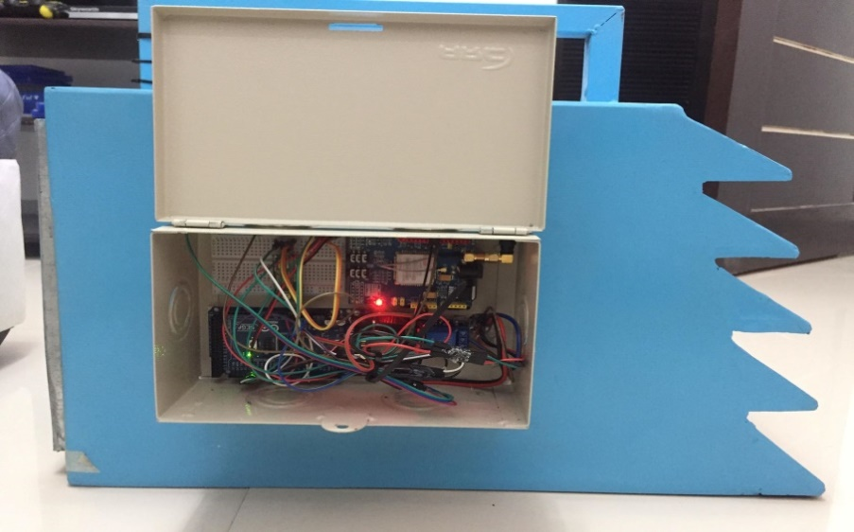

Computer Box of the machine

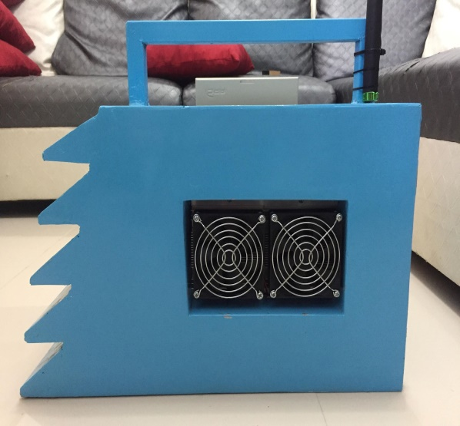

TEC Module

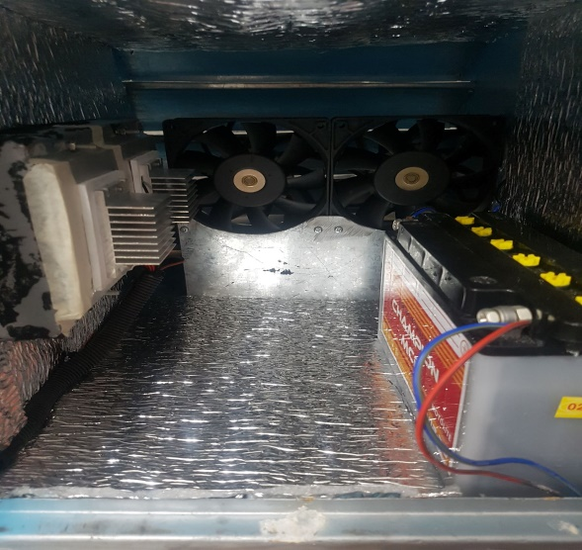

Inside of the machine

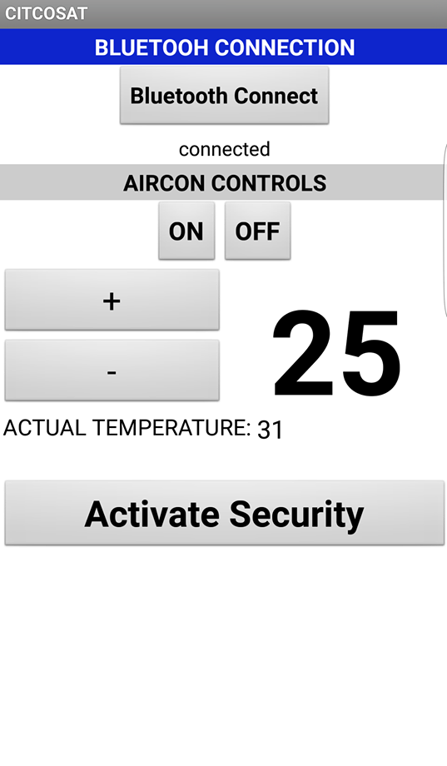

**Application Design**

**APPENDIX B**

**Tool and Equipment**

The following tools and equipment is used to develop the project study entitled “Car Interior Temperature Controlling System with Anti-theft Technology“.

**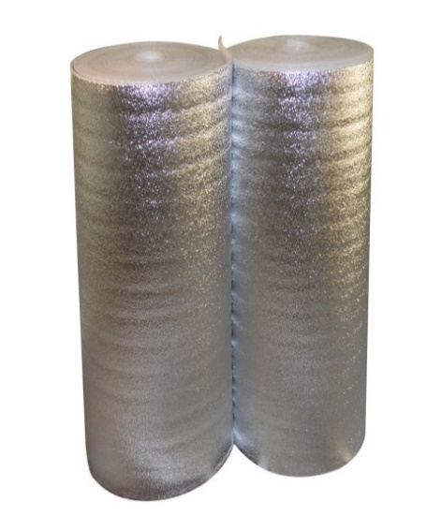**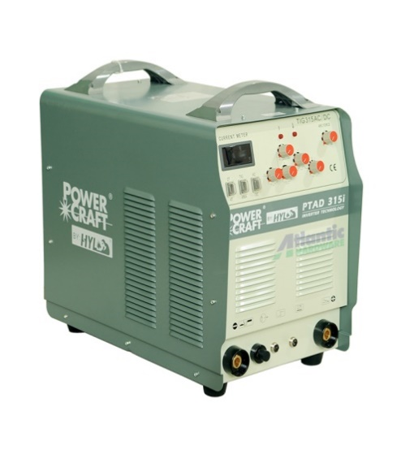

**Welding Machine Insulation Foam**

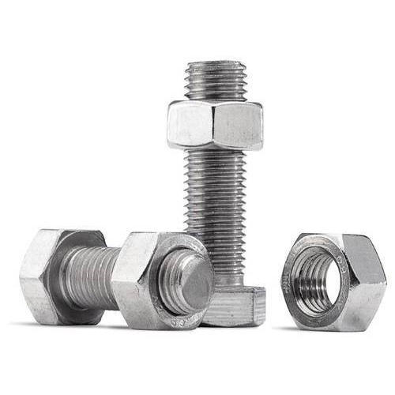 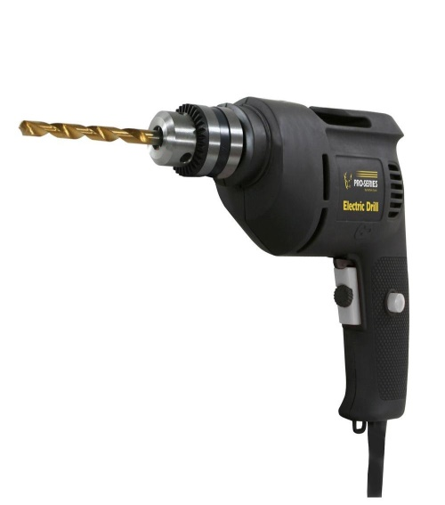

**Screw and Bolt Drill**

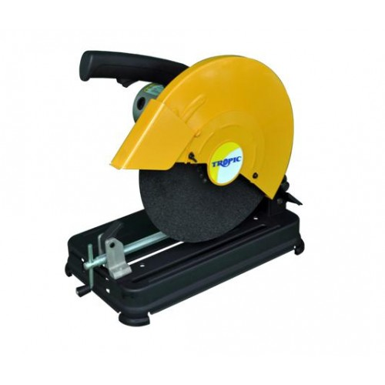 

**Speed Cutter L Square**

 

**Tape measures Glue Stick**

**APPENDIX C**

**Manual Operation**

**A. Operational Procedure for Car Interior Temperature Controlling System**:

1. Place the device anywhere inside the car, or even in the compartment.
2. Turn on the system and then open the mobile app.
3. Connect the mobile app to the system through bluetooth connection.
4. Set the value of the cooler and let the system on and let the car interior be cooled.

**For Anti-Theft Technology**

1. Turn on the system and then open the mobile app.
2. Connect the mobile app to the system through bluetooth connection.
3. Press the "insert button name" then wait for the SMS notification.

**B. Safety Precautions**

1. Keep things dry.
2. Regularly check the system.
3. Make sure to properly place the wires or even keep them hidden.

**C. Care and Maintenance**

1. Handle the system with care.
2. Clean the inside of the chassis every once in a while.
3. Regularly check the connection of every components in system.

**APPENDIX D**

**Wire/Connection Diagram**

**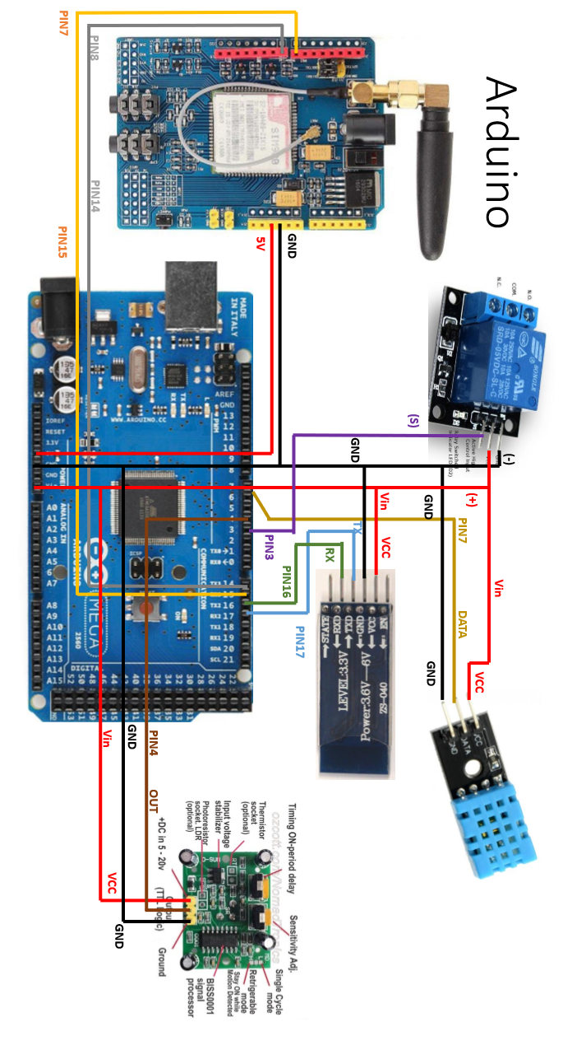**

**APPENDIX E**

**Performance Testing of the Device**

**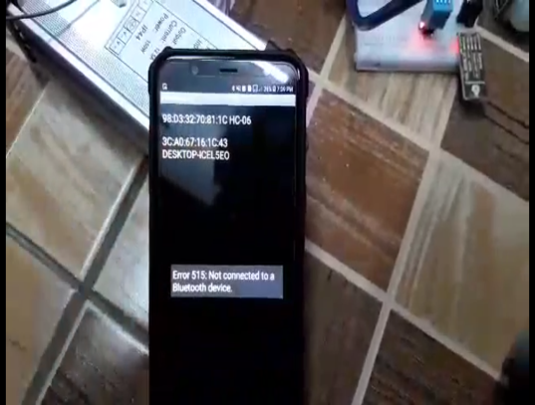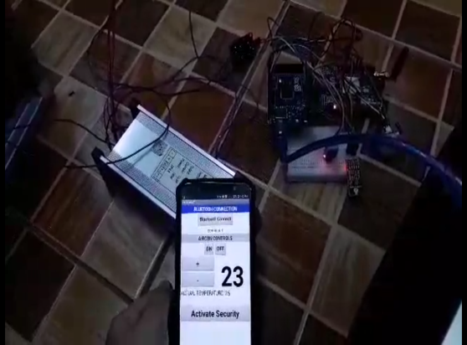**

**Connecting the app to machine Testing of the Cooling system**

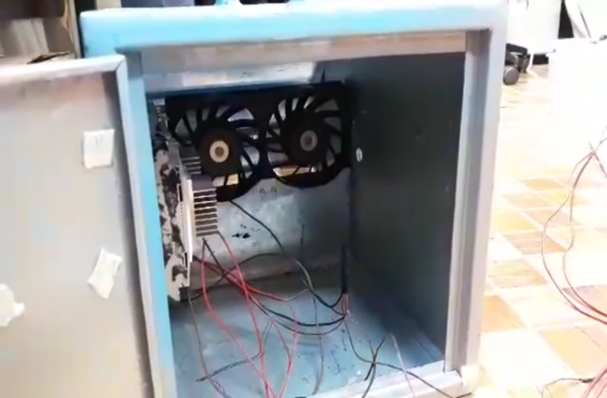

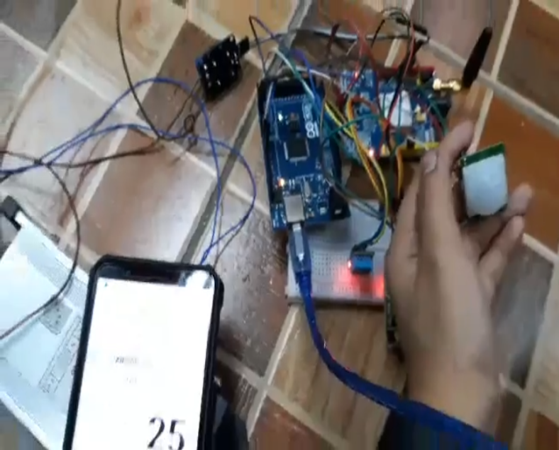

**Testing the PIR sensor**

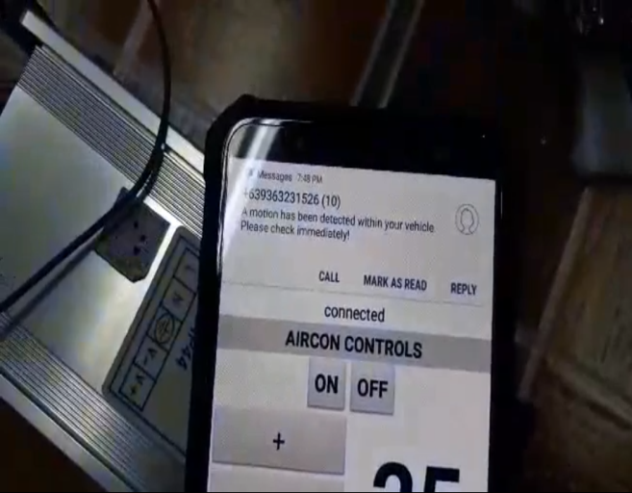

**Testing the of the device**

**APPENDIX F**

**Additional Design**

**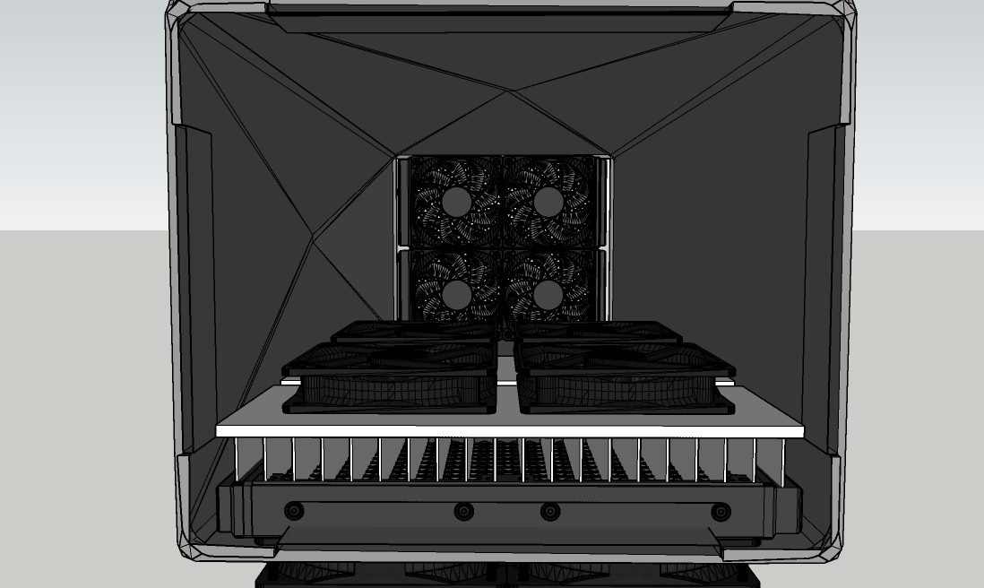**

**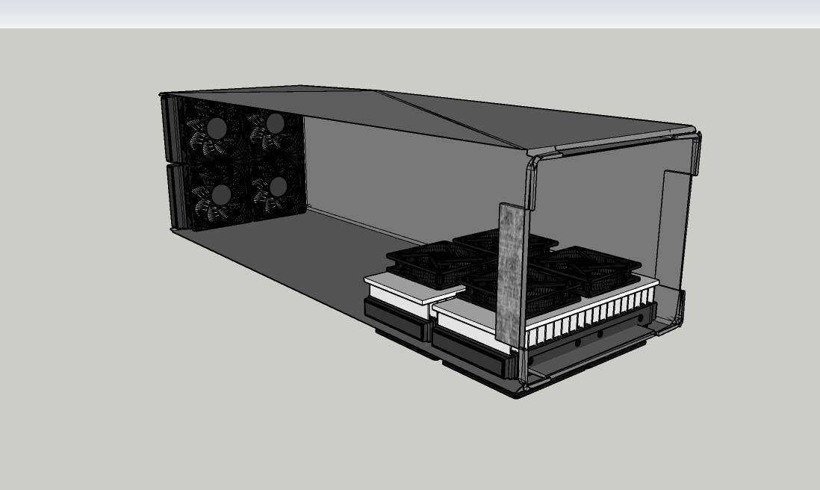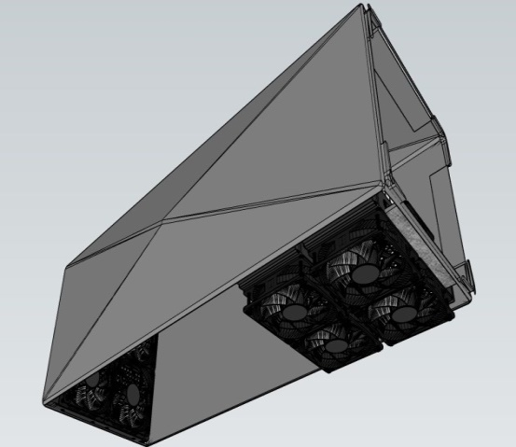**

**Car Interior Temperature Cooling System**

**APPENDIX G**

**Program Listing**

#include "dht.h"

/////////////////////////////////////////////////////

//

// PUBLIC

//

// return values:

// DHTLIB\_OK

// DHTLIB\_ERROR\_CHECKSUM

// DHTLIB\_ERROR\_TIMEOUT

int dht::read11(uint8\_t pin)

{

// READ VALUES

int rv = \_readSensor(pin, DHTLIB\_DHT11\_WAKEUP);

if (rv != DHTLIB\_OK)

{

humidity = DHTLIB\_INVALID\_VALUE; // invalid value, or is NaN prefered?

temperature = DHTLIB\_INVALID\_VALUE; // invalid value

return rv;

}

// CONVERT AND STORE

humidity = bits[0]; // bits[1] == 0;

temperature = bits[2]; // bits[3] == 0;

// TEST CHECKSUM

// bits[1] && bits[3] both 0

uint8\_t sum = bits[0] + bits[2];

if (bits[4] != sum) return DHTLIB\_ERROR\_CHECKSUM;

return DHTLIB\_OK;

}

// return values:

// DHTLIB\_OK

// DHTLIB\_ERROR\_CHECKSUM

// DHTLIB\_ERROR\_TIMEOUT

int dht::read(uint8\_t pin)

{

// READ VALUES

int rv = \_readSensor(pin, DHTLIB\_DHT\_WAKEUP);

if (rv != DHTLIB\_OK)

{

humidity = DHTLIB\_INVALID\_VALUE; // invalid value, or is NaN prefered?

temperature = DHTLIB\_INVALID\_VALUE; // invalid value

return rv; // propagate error value

}

// CONVERT AND STORE

humidity = word(bits[0], bits[1]) \* 0.1;

temperature = word(bits[2] & 0x7F, bits[3]) \* 0.1;

if (bits[2] & 0x80) // negative temperature

{

temperature = -temperature;

}

// TEST CHECKSUM

uint8\_t sum = bits[0] + bits[1] + bits[2] + bits[3];

if (bits[4] != sum)

{

return DHTLIB\_ERROR\_CHECKSUM;

}

return DHTLIB\_OK;

}

/////////////////////////////////////////////////////

//

// PRIVATE

//

// return values:

// DHTLIB\_OK

// DHTLIB\_ERROR\_TIMEOUT

int dht::\_readSensor(uint8\_t pin, uint8\_t wakeupDelay)

{

// INIT BUFFERVAR TO RECEIVE DATA

uint8\_t mask = 128;

uint8\_t idx = 0;

// replace digitalRead() with Direct Port Reads.

// reduces footprint ~100 bytes => portability issue?

// direct port read is about 3x faster

uint8\_t bit = digitalPinToBitMask(pin);

uint8\_t port = digitalPinToPort(pin);

volatile uint8\_t \*PIR = portInputRegister(port);

// EMPTY BUFFER

for (uint8\_t i = 0; i < 5; i++) bits[i] = 0;

// REQUEST SAMPLE

pinMode(pin, OUTPUT);

digitalWrite(pin, LOW); // T-be

delay(wakeupDelay);

digitalWrite(pin, HIGH); // T-go

delayMicroseconds(40);

pinMode(pin, INPUT);

// GET ACKNOWLEDGE or TIMEOUT

uint16\_t loopCntLOW = DHTLIB\_TIMEOUT;

while ((\*PIR & bit) == LOW ) // T-rel

{

if (--loopCntLOW == 0) return DHTLIB\_ERROR\_TIMEOUT;

}

uint16\_t loopCntHIGH = DHTLIB\_TIMEOUT;

while ((\*PIR & bit) != LOW ) // T-reh

{

if (--loopCntHIGH == 0) return DHTLIB\_ERROR\_TIMEOUT;

}

// READ THE OUTPUT - 40 BITS => 5 BYTES

for (uint8\_t i = 40; i != 0; i--)

{

loopCntLOW = DHTLIB\_TIMEOUT;

while ((\*PIR & bit) == LOW )

{

if (--loopCntLOW == 0) return DHTLIB\_ERROR\_TIMEOUT;

}

uint32\_t t = micros();

loopCntHIGH = DHTLIB\_TIMEOUT;

while ((\*PIR & bit) != LOW )

{

if (--loopCntHIGH == 0) return DHTLIB\_ERROR\_TIMEOUT;

}

if ((micros() - t) > 40)

{

bits[idx] |= mask;

}

mask >>= 1;

if (mask == 0) // next byte?

{

mask = 128;

idx++;

}

}

pinMode(pin, OUTPUT);

digitalWrite(pin, HIGH);

return DHTLIB\_OK;

}

**DHT-sensor-library-master (FOLDER)**

**DHT.CPP (file name)**

/\* DHT library

MIT license

written by Adafruit Industries

\*/

#include "DHT.h"

#define MIN\_INTERVAL 2000

DHT::DHT(uint8\_t pin, uint8\_t type, uint8\_t count) {

\_pin = pin;

\_type = type;

#ifdef \_\_AVR

\_bit = digitalPinToBitMask(pin);

\_port = digitalPinToPort(pin);

#endif

\_maxcycles = microsecondsToClockCycles(1000); // 1 millisecond timeout for

// reading pulses from DHT sensor.

// Note that count is now ignored as the DHT reading algorithm adjusts itself

// basd on the speed of the processor.

}

void DHT::begin(void) {

// set up the pins!

pinMode(\_pin, INPUT\_PULLUP);

// Using this value makes sure that millis() - lastreadtime will be

// >= MIN\_INTERVAL right away. Note that this assignment wraps around,

// but so will the subtraction.

\_lastreadtime = -MIN\_INTERVAL;

DEBUG\_PRINT("Max clock cycles: "); DEBUG\_PRINTLN(\_maxcycles, DEC);

}

//boolean S == Scale. True == Fahrenheit; False == Celcius

float DHT::readTemperature(bool S, bool force) {

float f = NAN;

if (read(force)) {

switch (\_type) {

case DHT11:

f = data[2];

if(S) {

f = convertCtoF(f);

}

break;

case DHT22:

case DHT21:

f = data[2] & 0x7F;

f \*= 256;

f += data[3];

f \*= 0.1;

if (data[2] & 0x80) {

f \*= -1;

}

if(S) {

f = convertCtoF(f);

}

break;

}

}

return f;

}

float DHT::convertCtoF(float c) {

return c \* 1.8 + 32;

}

float DHT::convertFtoC(float f) {

return (f - 32) \* 0.55555;

}

float DHT::readHumidity(bool force) {

float f = NAN;

if (read()) {

switch (\_type) {

case DHT11:

f = data[0];

break;

case DHT22:

case DHT21:

f = data[0];

f \*= 256;

f += data[1];

f \*= 0.1;

break;

}

}

return f;

}

//boolean isFahrenheit: True == Fahrenheit; False == Celcius

float DHT::computeHeatIndex(float temperature, float percentHumidity, bool isFahrenheit) {

// Using both Rothfusz and Steadman's equations

// http://www.wpc.ncep.noaa.gov/html/heatindex\_equation.shtml

float hi;

if (!isFahrenheit)

temperature = convertCtoF(temperature);

hi = 0.5 \* (temperature + 61.0 + ((temperature - 68.0) \* 1.2) + (percentHumidity \* 0.094));

if (hi > 79) {

hi = -42.379 +

2.04901523 \* temperature +

10.14333127 \* percentHumidity +

-0.22475541 \* temperature\*percentHumidity +

-0.00683783 \* pow(temperature, 2) +

-0.05481717 \* pow(percentHumidity, 2) +

0.00122874 \* pow(temperature, 2) \* percentHumidity +

0.00085282 \* temperature\*pow(percentHumidity, 2) +

-0.00000199 \* pow(temperature, 2) \* pow(percentHumidity, 2);

if((percentHumidity < 13) && (temperature >= 80.0) && (temperature <= 112.0))

hi -= ((13.0 - percentHumidity) \* 0.25) \* sqrt((17.0 - abs(temperature - 95.0)) \* 0.05882);

else if((percentHumidity > 85.0) && (temperature >= 80.0) && (temperature <= 87.0))

hi += ((percentHumidity - 85.0) \* 0.1) \* ((87.0 - temperature) \* 0.2);

}

return isFahrenheit ? hi : convertFtoC(hi);

}

boolean DHT::read(bool force) {

// Check if sensor was read less than two seconds ago and return early

// to use last reading.

uint32\_t currenttime = millis();

if (!force && ((currenttime - \_lastreadtime) < 2000)) {

return \_lastresult; // return last correct measurement

}

\_lastreadtime = currenttime;

// Reset 40 bits of received data to zero.

data[0] = data[1] = data[2] = data[3] = data[4] = 0;

// Send start signal. See DHT datasheet for full signal diagram:

// http://www.adafruit.com/datasheets/Digital%20humidity%20and%20temperature%20sensor%20AM2302.pdf

// Go into high impedence state to let pull-up raise data line level and

// start the reading process.

digitalWrite(\_pin, HIGH);

delay(250);

// First set data line low for 20 milliseconds.

pinMode(\_pin, OUTPUT);

digitalWrite(\_pin, LOW);

delay(20);

uint32\_t cycles[80];

{

// Turn off interrupts temporarily because the next sections are timing critical

// and we don't want any interruptions.

InterruptLock lock;

// End the start signal by setting data line high for 40 microseconds.

digitalWrite(\_pin, HIGH);

delayMicroseconds(40);

// Now start reading the data line to get the value from the DHT sensor.

pinMode(\_pin, INPUT\_PULLUP);

delayMicroseconds(10); // Delay a bit to let sensor pull data line low.

// First expect a low signal for ~80 microseconds followed by a high signal

// for ~80 microseconds again.

if (expectPulse(LOW) == 0) {

DEBUG\_PRINTLN(F("Timeout waiting for start signal low pulse."));

\_lastresult = false;

return \_lastresult;

}

if (expectPulse(HIGH) == 0) {

DEBUG\_PRINTLN(F("Timeout waiting for start signal high pulse."));

\_lastresult = false;

return \_lastresult;

}

// Now read the 40 bits sent by the sensor. Each bit is sent as a 50

// microsecond low pulse followed by a variable length high pulse. If the

// high pulse is ~28 microseconds then it's a 0 and if it's ~70 microseconds

// then it's a 1. We measure the cycle count of the initial 50us low pulse

// and use that to compare to the cycle count of the high pulse to determine

// if the bit is a 0 (high state cycle count < low state cycle count), or a

// 1 (high state cycle count > low state cycle count). Note that for speed all

// the pulses are read into a array and then examined in a later step.

for (int i=0; i<80; i+=2) {

cycles[i] = expectPulse(LOW);

cycles[i+1] = expectPulse(HIGH);

}

} // Timing critical code is now complete.

// Inspect pulses and determine which ones are 0 (high state cycle count < low

// state cycle count), or 1 (high state cycle count > low state cycle count).

for (int i=0; i<40; ++i) {

uint32\_t lowCycles = cycles[2\*i];

uint32\_t highCycles = cycles[2\*i+1];

if ((lowCycles == 0) || (highCycles == 0)) {

DEBUG\_PRINTLN(F("Timeout waiting for pulse."));

\_lastresult = false;

return \_lastresult;

}

data[i/8] <<= 1;

// Now compare the low and high cycle times to see if the bit is a 0 or 1.

if (highCycles > lowCycles) {

// High cycles are greater than 50us low cycle count, must be a 1.

data[i/8] |= 1;

}

// Else high cycles are less than (or equal to, a weird case) the 50us low

// cycle count so this must be a zero. Nothing needs to be changed in the

// stored data.

}

DEBUG\_PRINTLN(F("Received:"));

DEBUG\_PRINT(data[0], HEX); DEBUG\_PRINT(F(", "));

DEBUG\_PRINT(data[1], HEX); DEBUG\_PRINT(F(", "));

DEBUG\_PRINT(data[2], HEX); DEBUG\_PRINT(F(", "));

DEBUG\_PRINT(data[3], HEX); DEBUG\_PRINT(F(", "));

DEBUG\_PRINT(data[4], HEX); DEBUG\_PRINT(F(" =? "));

DEBUG\_PRINTLN((data[0] + data[1] + data[2] + data[3]) & 0xFF, HEX);

// Check we read 40 bits and that the checksum matches.

if (data[4] == ((data[0] + data[1] + data[2] + data[3]) & 0xFF)) {

\_lastresult = true;

return \_lastresult;

}

else {

DEBUG\_PRINTLN(F("Checksum failure!"));

\_lastresult = false;

return \_lastresult;

}

}

// Expect the signal line to be at the specified level for a period of time and

// return a count of loop cycles spent at that level (this cycle count can be

// used to compare the relative time of two pulses). If more than a millisecond

// ellapses without the level changing then the call fails with a 0 response.

// This is adapted from Arduino's pulseInLong function (which is only available

// in the very latest IDE versions):

// https://github.com/arduino/Arduino/blob/master/hardware/arduino/avr/cores/arduino/wiring\_pulse.c

uint32\_t DHT::expectPulse(bool level) {

uint32\_t count = 0;

// On AVR platforms use direct GPIO port access as it's much faster and better

// for catching pulses that are 10's of microseconds in length:

#ifdef \_\_AVR

uint8\_t portState = level ? \_bit : 0;

while ((\*portInputRegister(\_port) & \_bit) == portState) {

if (count++ >= \_maxcycles) {

return 0; // Exceeded timeout, fail.

}

}

// Otherwise fall back to using digitalRead (this seems to be necessary on ESP8266

// right now, perhaps bugs in direct port access functions?).

#else

while (digitalRead(\_pin) == level) {

if (count++ >= \_maxcycles) {

return 0; // Exceeded timeout, fail.

}

}

#endif

return count;

}

**DHT\_U.cpp (file name)**

#include "DHT\_U.h"

DHT\_Unified::DHT\_Unified(uint8\_t pin, uint8\_t type, uint8\_t count, int32\_t tempSensorId, int32\_t humiditySensorId):

\_dht(pin, type, count),

\_type(type),

\_temp(this, tempSensorId),

\_humidity(this, humiditySensorId)

{}

void DHT\_Unified::begin() {

\_dht.begin();

}

void DHT\_Unified::setName(sensor\_t\* sensor) {

switch(\_type) {

case DHT11:

strncpy(sensor->name, "DHT11", sizeof(sensor->name) - 1);

break;

case DHT21:

strncpy(sensor->name, "DHT21", sizeof(sensor->name) - 1);

break;

case DHT22:

strncpy(sensor->name, "DHT22", sizeof(sensor->name) - 1);

break;

default:

// TODO: Perhaps this should be an error? However main DHT library doesn't enforce

// restrictions on the sensor type value. Pick a generic name for now.

strncpy(sensor->name, "DHT?", sizeof(sensor->name) - 1);

break;

}

sensor->name[sizeof(sensor->name)- 1] = 0;

}

void DHT\_Unified::setMinDelay(sensor\_t\* sensor) {

switch(\_type) {

case DHT11:

sensor->min\_delay = 1000000L; // 1 second (in microseconds)

break;

case DHT21:

sensor->min\_delay = 2000000L; // 2 seconds (in microseconds)

break;

case DHT22:

sensor->min\_delay = 2000000L; // 2 seconds (in microseconds)

break;

default:

// Default to slowest sample rate in case of unknown type.

sensor->min\_delay = 2000000L; // 2 seconds (in microseconds)

break;

}

}

DHT\_Unified::Temperature::Temperature(DHT\_Unified\* parent, int32\_t id):

\_parent(parent),

\_id(id)

{}

bool DHT\_Unified::Temperature::getEvent(sensors\_event\_t\* event) {

// Clear event definition.

memset(event, 0, sizeof(sensors\_event\_t));

// Populate sensor reading values.

event->version = sizeof(sensors\_event\_t);

event->sensor\_id = \_id;

event->type = SENSOR\_TYPE\_AMBIENT\_TEMPERATURE;

event->timestamp = millis();

event->temperature = \_parent->\_dht.readTemperature();

return true;

}

void DHT\_Unified::Temperature::getSensor(sensor\_t\* sensor) {

// Clear sensor definition.

memset(sensor, 0, sizeof(sensor\_t));

// Set sensor name.

\_parent->setName(sensor);

// Set version and ID

sensor->version = DHT\_SENSOR\_VERSION;

sensor->sensor\_id = \_id;

// Set type and characteristics.

sensor->type = SENSOR\_TYPE\_AMBIENT\_TEMPERATURE;

\_parent->setMinDelay(sensor);

switch (\_parent->\_type) {

case DHT11:

sensor->max\_value = 50.0F;

sensor->min\_value = 0.0F;

sensor->resolution = 2.0F;

break;

case DHT21:

sensor->max\_value = 80.0F;

sensor->min\_value = -40.0F;

sensor->resolution = 0.1F;

break;

case DHT22:

sensor->max\_value = 125.0F;

sensor->min\_value = -40.0F;

sensor->resolution = 0.1F;

break;

default:

// Unknown type, default to 0.

sensor->max\_value = 0.0F;

sensor->min\_value = 0.0F;

sensor->resolution = 0.0F;

break;

}

}

DHT\_Unified::Humidity::Humidity(DHT\_Unified\* parent, int32\_t id):

\_parent(parent),

\_id(id)

{}

bool DHT\_Unified::Humidity::getEvent(sensors\_event\_t\* event) {

// Clear event definition.

memset(event, 0, sizeof(sensors\_event\_t));

// Populate sensor reading values.

event->version = sizeof(sensors\_event\_t);

event->sensor\_id = \_id;

event->type = SENSOR\_TYPE\_RELATIVE\_HUMIDITY;

event->timestamp = millis();

event->relative\_humidity = \_parent->\_dht.readHumidity();

return true;

}

void DHT\_Unified::Humidity::getSensor(sensor\_t\* sensor) {

// Clear sensor definition.

memset(sensor, 0, sizeof(sensor\_t));

// Set sensor name.

\_parent->setName(sensor);

// Set version and ID

sensor->version = DHT\_SENSOR\_VERSION;

sensor->sensor\_id = \_id;

// Set type and characteristics.

sensor->type = SENSOR\_TYPE\_RELATIVE\_HUMIDITY;

\_parent->setMinDelay(sensor);

switch (\_parent->\_type) {

case DHT11:

sensor->max\_value = 80.0F;

sensor->min\_value = 20.0F;

sensor->resolution = 5.0F;

break;

case DHT21:

sensor->max\_value = 100.0F;

sensor->min\_value = 0.0F;

sensor->resolution = 0.1F;

break;

case DHT22:

sensor->max\_value = 100.0F;

sensor->min\_value = 0.0F;

sensor->resolution = 0.1F;

break;

default:

// Unknown type, default to 0.

sensor->max\_value = 0.0F;

sensor->min\_value = 0.0F;

sensor->resolution = 0.0F;

break;

}

}

|  |  |
| --- | --- |
| **MARK DANIEL ABIS BONDOC**  Address: #122 Burgos St. Brgy. Salac, Lumban, Laguna, Phils.  Mobile No: (0928) 497 5011  E-mail Address: markdanielbondoc0802@gmail.com.ph | ID_PIC |

|  |
| --- |
| **CAREER OBJECTIVES** |

Seeking a challenging position with a progressive organization that provides an opportunity to capitalize my technical skills & abilities in the field of Software/Hardware Engineering.

|  |
| --- |
| **EDUCATION** |

Tertiary Level : Laguna State Polytechnic University

Address : Santa Cruz Main Campus, Santa Cruz, Laguna, Philippines

Course : Bachelor of Science in Computer Engineering

Inclusive Year : 2014 to Present

Secondary Level : Lumban Academy Nitanny School, Inc.

Address : Lumban, Laguna, Philippines

Inclusive Year : 2008 to 2012

|  |
| --- |
| **PERSONAL PROFILE** |

Birth Date : August 02, 1995

Birth Place : Apalit Pampanga, Philippines

Civil Status : Single

Gender : Male

Citizenship : Filipino

Religion : Iglesia Ni Cristo

Height : 5’10”

Weight : 85kg

Languages : Tagalog and English

|  |
| --- |
| **SKILLS AND QUALITIES** |

* Knowledgeable in Autocad, Computer Hardware and Software
* Can communicate both oral and written
* Highly motivated
* Very creative and hardworking
* Entry – level Programming (C#, C++, HTML, )
* Database Management System

|  |
| --- |
| **SEMINARS/TRAININGS** |

**CpEYESTA 2015:ICpEP.SE REGION IVA FIRST REGIONAL ASSEMBLY**

Theme: “Camaraderie, Paving the way for future Engineers” Seminar on Arduino Microcontroller | Cyber Security: Tackling the Challenges of Securing the Cyber space | Business Blogging | Job Opportunities with PLC

December 05, 2015 | Lyceum of the Philippines University – Batangas

**SAFETY MANAGEMENT AND ENGINEERING**

Theme:” impact of safety Management in workplace”

December 04, 2017 | Laguna State Polytechnic University – Sta. Cruz Campus

**2018 ICpEP. SE GENERAL ASSEMBLY AND CpEYESTA**

Theme:” The Question for One ICpEP Towards Professionalism and Collaboration”

Seminar on Entreprenuerial Mindset: Creating a Culture of Innovation, Industrial Robots, the weakest Link: Human Error Conquered, and Machine learning

October 06, 2018 | Colegio de San Juan de Letran Calamba, Calamba City, Laguna, Philippines

**MACHINE LEARNING SUMMIT 2019**

Theme:” Machine Learning if the future”

Topic: Predictive Modeling |Statistics for Machine Learning | Data Mining Techniques | Machine Learning Python

February 25, 2019 | Pacita Astrodome, City of San Pedro, Laguna

**Gender Sensitivity Training for Graduating Students College of Engineering Laguna State Polytechnic University, Santa Cruz Main Campus Date, LSPU-SCC University Gymnasium**

April 08, 2019 | Laguna State Polytechnic University – Sta. Cruz Campus

|  |
| --- |
| **WORKING EXPERIENCES** |

**Diadem Business Solutions**

Brgy. Mahogany Cabuyao, Laguna

Data Technician

*December 12, 2012 - May 16, 2014*

**First Laguna Electric Cooperative, Inc. (FLECO)**

Brgy. Lewin National Highway Lumban, Laguna

OJT, assigned in Engineering Department

*June 18, 2018 - July 26, 2018*

*I hereby certify that above information are true and correct to the best of my knowledge and belief.*

Mark Daniel A. Bondoc

|  |  |
| --- | --- |
| **RAMMIELLE ABELLA GABALEÑO**  Address: Brgy. Sampaloc, Pagsanjan, Laguna, Phils.  Mobile No: (0998) 323 7333  E-mail Address: ramgabaleno21@yahoo.com.ph |  |

|  |
| --- |
| **CAREER OBJECTIVES** |

To secure a suitable challenging and growth oriented position for qualification where I can best utilize my knowledge and pull potentials that would enable my personality and professional growth so as to contribute to the organization.

|  |
| --- |
| **EDUCATION** |

Tertiary Level : Laguna State Polytechnic University

Address : Santa Cruz Main Campus, Santa Cruz, Laguna, Philippines

Course : Bachelor of Science in Computer Engineering

Inclusive Year : 2014 to Present

Secondary Level : Pagsanjan Academy

Address : Pagsanjan, Laguna, Philippines

Inclusive Year : 2010 to 2014

|  |
| --- |
| **PERSONAL PROFILE** |

Birth Date : May 21, 1996

Birth Place : Bgry. Sampaloc, Pagsanjan, Laguna, Philippines

Civil Status : Single

Gender : Male

Citizenship : Filipino

Religion : Iglesia Ni Cristo

Height : 5’5”

Weight : 70kg

Languages : Tagalog and English

|  |
| --- |
| **SKILLS AND QUALITIES** |

* Knowledgeable in Autocad, Computer Hardware and Software
* Can communicate both oral and written
* Highly motivated
* Very creative and hardworking
* Entry – level Programming (C#, C++, HTML, )
* Database Management System

|  |
| --- |
| **SEMINARS/TRAININGS** |

**CpEYESTA 2015:ICpEP.SE REGION IVA FIRST REGIONAL ASSEMBLY**

Theme: “Camaraderie, Paving the way for future Engineers” Seminar on Arduino Microcontroller | Cyber Security: Tackling the Challenges of

Securing the Cyber space | Business Blogging | Job Opportunities with PLC

December 05, 2015 | Lyceum of the Philippines University – Batangas

**SAFETY MANAGEMENT AND ENGINEERING**

Theme:” impact of safety Management in workplace”

December 04, 2017 | Laguna State Polytechnic University – Sta. Cruz Campus

**2018 ICpEP. SE GENERAL ASSEMBLY AND CpEYESTA**

Theme:” The Question for One ICpEP Towards Professionalism and Collaboration”

Seminar on Entreprenuerial Mindset: Creating a Culture of Innovation, Industrial Robots, the weakest Link: Human Error Conquered, and Machine learning

October 06, 2018 | Colegio de San Juan de Letran Calamba, Calamba City, Laguna, Philippines

**MACHINE LEARNING SUMMIT 2019**

Theme:” Machine Learning if the future”

Topic: Predictive Modeling |Statistics for Machine Learning | Data Mining Techniques | Machine Learning Python

February 25, 2019 | Pacita Astrodome, City of San Pedro, Laguna

**Gender Sensitivity Training for Graduating Students College of Engineering Laguna State Polytechnic University, Santa Cruz Main Campus Date, LSPU-SCC University Gymnasium**

April 08, 2019 | Laguna State Polytechnic University – Sta.Cruz Campus

|  |
| --- |
| **WORKING EXPERIENCES** |

SUNSTAR MALL – URBAN PARK INC.

National Highway, Brgy. Gatid, Sta.Cruz Laguna

OJT, assigned in Administration Office

October 02, 2018 – November 27, 201

*I hereby certify that above information are true and correct to the best of my knowledge and belief.*

Rammielle A. Gabaleño

|  |  |
| --- | --- |
| **ALLEN MESINA VERIDIANO**  Address: Brgy. Calios, Sta. Cruz Laguna  Mobile No: (0929) 305 3678  E-mail Address: allenveridiano@gmail.com |  |



|  |
| --- |
| **CAREER OBJECTIVES** |

To secure a suitable challenging and growth oriented position for qualification where I can best utilize my knowledge and pull potentials that would enable my personality and professional growth so as to contribute to the organization.

|  |
| --- |
| **EDUCATION** |

Tertiary Level : Laguna State Polytechnic University

Address : Brgy. Bubukal, Sta. Cruz Laguna

Course : Bachelor of Science in Computer Engineering

Inclusive Year : 2014 to Present

Secondary Level : Laguna State Polytechnic University – Santa Cruz

Address : Brgy. Bubukal, Sta. Cruz Laguna

Inclusive Year : 2010 to 2014

Primary Level : Burol Elementary School

Address : Cavinti, Laguna

|  |
| --- |
| **PERSONAL PROFILE** |

Birth Date : September 13, 1998

Birth Place : Sta. Cruz, Laguna

Civil Status : Single

Gender : Male

Citizenship : Filipino

Religion : Roman Catholic

Height : 5’11”

Weight : 62kg

Languages : Tagalog and English

|  |
| --- |
| **SKILLS AND QUALITIES** |

* Knowledgeable in AutoCAD, Computer Hardware and Software
* Can communicate both oral and written
* Highly motivated
* Adobe Software (Photoshop, AfterFX, Premiere)
* Very creative and hardworking
* Entry – level Programming (C#, C++, HTML, PHP)
* Database Management System

|  |
| --- |
| **SEMINARS/TRAININGS** |

**CpEYESTA 2015:ICpEP.SE REGION IVA FIRST REGIONAL ASSEMBLY**

Theme: “Camaraderie, Paving the way for future Engineers” Seminar on Arduino Microcontroller | Cyber Security: Tackling the Challenges of

Securing the Cyber space | Business Blogging | Job Opportunities with PLC

December 05, 2015 | Lyceum of the Philippines University – Batangas

**SAFETY MANAGEMENT AND ENGINEERING**

Theme:” impact of safety Management in workplace”

December 04, 2017 | Laguna State Polytechnic University – Sta. Cruz Campus

**2018 ICpEP. SE GENERAL ASSEMBLY AND CpEYESTA**

Theme:” The Question for One ICpEP Towards Professionalism and Collaboration”

Seminar on Entreprenuerial Mindset: Creating a Culture of Innovation, Industrial Robots, the weakest Link: Human Error Conquered, and Machine learning

October 06, 2018 | Colegio de San Juan de Letran Calamba, Calamba City, Laguna, Philippines

**MACHINE LEARNING SUMMIT 2019**

Theme:” Machine Learning if the future”

Topic: Predictive Modeling |Statistics for Machine Learning | Data Mining Techniques | Machine Learning Python

February 25, 2019 | Pacita Astrodome, City of San Pedro, Laguna

**Gender Sensitivity Training for Graduating Students College of Engineering Laguna State Polytechnic University, Santa Cruz Main Campus Date, LSPU-SCC University Gymnasium**

April 08, 2019 | Laguna State Polytechnic University – Sta.Cruz Campus

**INTO THE WEB-VERSE**

Topic: PHP Programming with Database Management System

February 03 – March 05, 2019 | Laguna State Polytechnic University – Santa Cruz Campus

|  |
| --- |
| **WORKING EXPERIENCES** |

SUNSTAR MALL – URBAN PARK INC.

National Highway, Brgy. Gatid, Sta.Cruz Laguna

OJT, assigned in Administration Office

October 02, 2018 – November 27, 2018

*I hereby certify that above information are true and correct to the best of my knowledge and belief.*

Allen M. Veridiano